**INDEX**

|  |  |  |  |
| --- | --- | --- | --- |
| **No.** | **Contents** | **Page no.** | **File name** |
|  | **Goal / Overview of Project** | **4** |  |
| **1.** | **Platform setting / Configuration procedure** | **5** |  |
| **2.** | **What our data contents and selected features description.** | **7** |  |
| **3.** | **Part 1: Data Preprocessing Steps and Intermediate Outputs** | **8** | **Python** |
|  | * **Finding Z-Score and IQR** | **20** |  |
|  | * **Text Cleaning process** | **21** |  |
|  | * **Tokenization** | **23** |  |
| **4.** | **Part 2:** | **25** | **Untitled1** |
|  | * **Pie chart** | **27** |  |
|  | * **Stopwords, Wordclouds** | **32** |  |
| **5** | **Part 3:** | **35** | **Low rating analysis** |
|  | * **Age group visualization** | **38** |  |
|  | * **Pivot table** | **39** |  |
|  | * **Categorize with age** | **40** |  |
| **6** | **Part 4: Deep learning** | **46** | **db_one_data** |
|  | * **Word Embedding** | **51** |  |
|  | * **Result** | **56** |  |
|  | **References** | **59** |  |

**Goal:**

We are finding the clothing product is good or bad, by doing text analysis from that product review data, and find the major reason on current data.

**Overview of Project:**

First the major problem, we are finding the problem which customer are facing.

* To Resolve that, we are trying to do text analysis.

1. Data cleaning
2. Comparison

* With the help of Deep Learning, will find the positive or negative review

1. Vectorization
2. Model training

**1. Platform Setting/Configuration Procedure: -**

* We are used Visual Studio Code Software Platform, because it is versatile source code editor developed by Microsoft. It has features like Syntax highlighting, debugging.
* We have used Python programming Language because it supports multiple programming

and making it widely used for data analysis, artificial intelligence and Machine Learning.

* Jupyter Notebook Editor for the configuration of each task, it allows us to create an equations and visualizations and narrative text. Used for data science and scientific computing.
* We have used Scikit-Learn is machine learning library for python. Good tool for data analysis, modeling and some classification like regression, algorithms and mostly used to build on NumPy, SciPy, Matplotib.
* Google colab is cloud-based platform by google, it provides free access to GPU resources and supported for machine learning and data analysis.
* TensorFlow: It is an open-source machine learning framework by google. We have used for building and training deep learning model.

1. **Visual Studio Code: 2. Python: 3. Jupyter Notebook:**

  

**4. Scikit-Learn: 5. Google Colab 6. TensorFlow:**

  

**2. What Our Data Contents, Selected Feature Description: -**

* **DATASET:** These datasets contain measurements of clothing fit from *ModCloth* and *RentTheRunway.*

**{ "fit": "fit",**

**"user_id": "420272",**

**"bust size": "34d",**

**"item_id": "2260466",**

**"weight": "137lbs",**

**"rating": "10",**

**"rented for": "vacation",**

**"review_text": "An adorable romper! Belt and zipper were a little hard to navigate in a full day of wear/bathroom use, but that's to be expected. Wish it had pockets, but other than that-- absolutely perfect! I got a million compliments.", "body type": "hourglass",**

**"review_summary": "So many compliments!",**

**"category": "romper",**

**"height": "5' 8\"",**

**"size": 14,**

**"age": "28",**

**"review_date":**

**"April 20, 2016" }**

* **Data link:**

https://cseweb.ucsd.edu/~jmcauley/datasets.html#amazon_reviews

* After confirming and discussing taking this dataset, it was in a JSON file. So, we Convert this file into an Excel (.csv) file to use for our project.
* While converting we get some data misplaced because some values in JSON is missing so we get the disorganization of data, we have to solve that problem to get appropriate data for our further analysis.
* **Data Contents**: -

Our Data Contents this fields:

**fit, user_id, bust size, item_id, weight, rating, rented for, review_text, body type, review_summary, category, height, size, age, review_date**

* First, our data was around **1,92,543** including columns and rows.

|  |  |  |
| --- | --- | --- |
| **Attribute Name** | **Type** | **Description and values** |
| **fit** | **Nominal** | **Shows that it fits or does not** |
| **User id** | **Numeric** | **Uniq ID of the user on data set** |
| **bust size** | **ordinal** | **Represent the size** |
| **Item id** | **Numeric** | **Unique id of item in data set** |
| **weight** | **Numeric** | **It represents the weight** |
| **rating** | **Numeric** | **Shows the data in numeric where 10 is good** |
| **rented for** | **Nominal** | **Clothes are rented for occasions or other things** |
| **review text** | **Text** | **Their personal reviews on items and experience** |
| **body type** | **Nominal** | **Describe the user's body type** |
| **review summary** | **Text** | **This is a short review of the user** |
| **category** | **Nominal** | **Specify the cloth category** |
| **height** | **Numeric** | **Height of user** |
| **size** | **Numeric** | **Size of user cloth** |
| **age** | **Numeric** | **Age of user** |
| **Review date** | **Numeric** | **Date of review** |

**Selected Feature Description:**

* As we discussed with a professor about our project our main goal is text analysis, so we decided to select some feathers that are important for our text analysis to understand user behavior and find the insides of data.
* For the text analysis, we are using these features for now, and with further calculation of text analysis and behavior analysis we could use the other columns to reach the desired output.
* **Main features of text analysis**

o **Rating**

o **review text**

o **review summary**

o **Item id**

o **category**

1. **Data Preprocessing Steps and the Intermediate Outputs: -**

**File name : python**

* Here we started data preprocessing methods

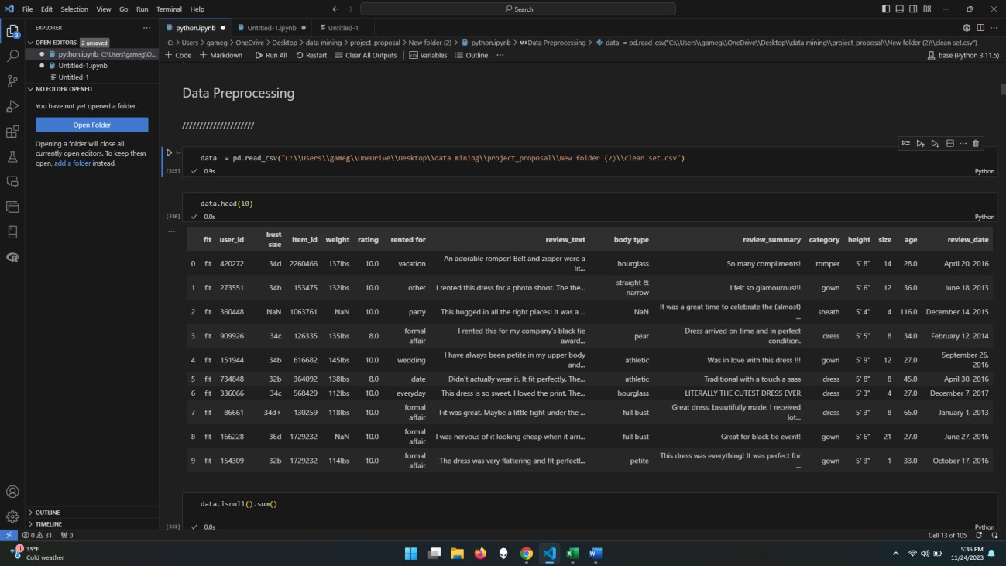

* Getting the data from CSV file into a data variable
* And for our understanding we are showing the data.head of 10 rows to identify data style.

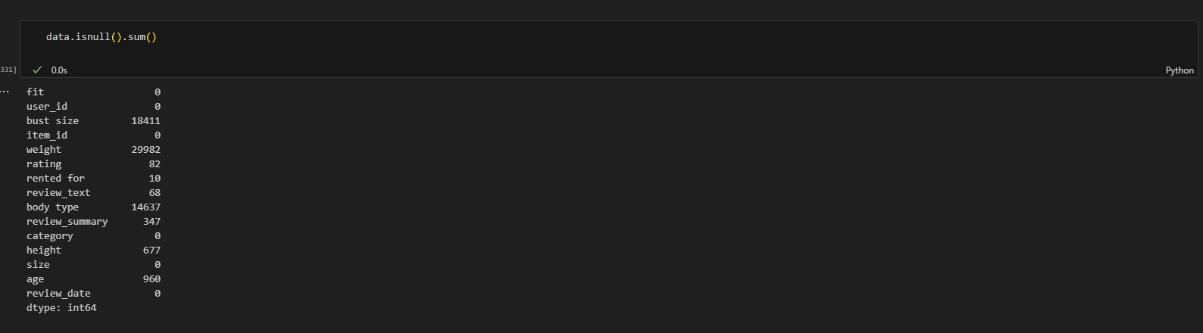

* Now here we are checking the null values of data because we must remove that before starting the further process.

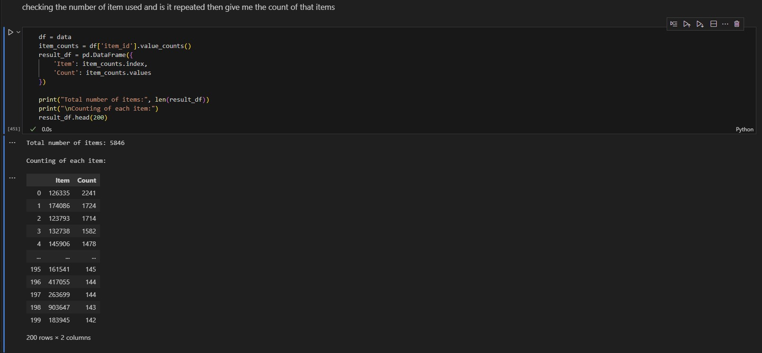

* Now Here, we have to check how many different items are in the data because we have more than 5846 items and according to that we have the get the mean values of each column and it should be in item wise because if we do the mean of the whole data then it is wrong data replacement, because our data is diverse by items and each item has the own rating and reviews. So, if we do mean of whole data and replace that in null values then it creates misleading data. And we don’t want that.

* So, here we are finding the items and how many times it is repeated according to that we get the mean of that and finding the mean of each column for each item_id and replace that with null values to achieve nearest appropriate data.

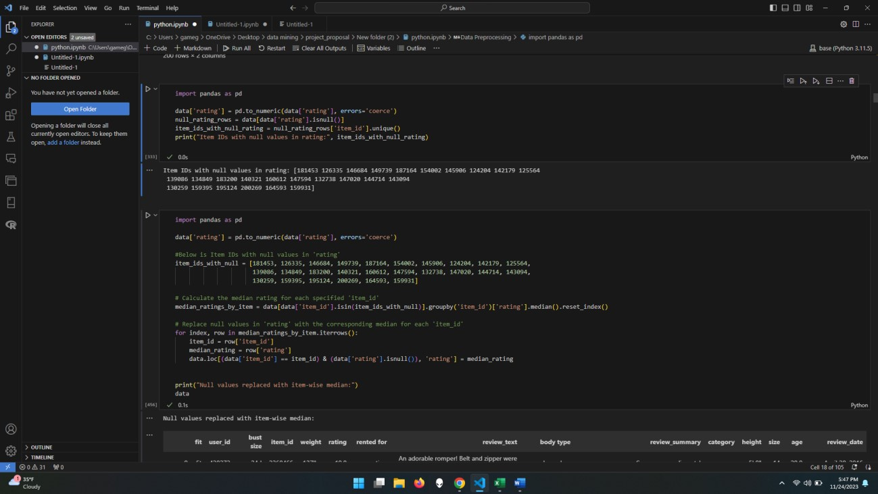

* Here we are getting the item_id of the rating which is null. So, we can replace that with the mean values of each items mean:

1. Get the item ids

* Item IDs with null values in rating:

**[181453 126335 146684 149739 187164 154002 145906 124204 142179 125564 139086 134849 183200 140321 160612 147594 132738 147020 144714 143094 130259 159395 195124 200269 164593 159931]**

1. Replacing the null values with each item (mean) in the columns of rating.

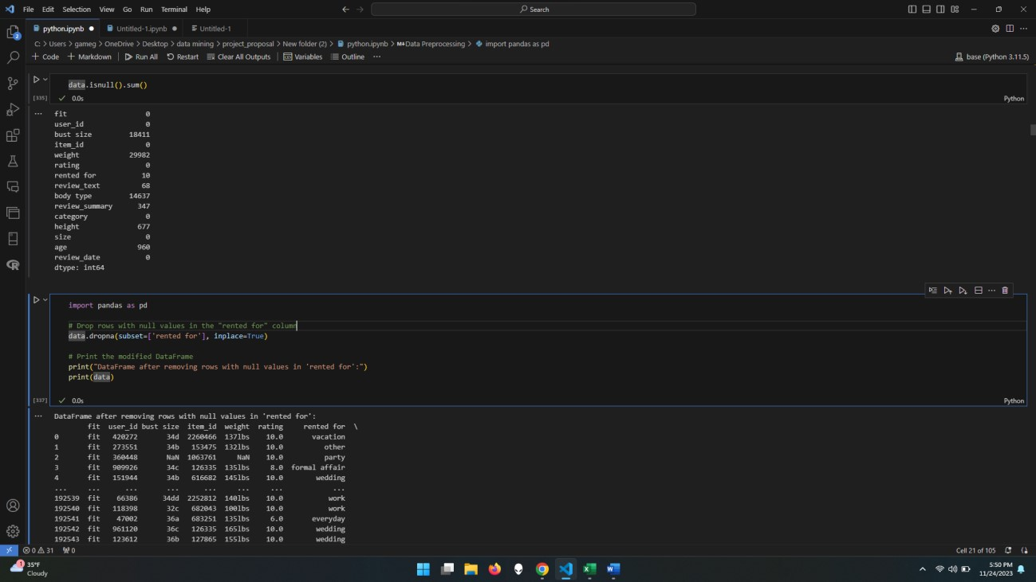

* Here, we are checking the null values of data, where we can see that (rented for) has the 10 null values, however it is text format so we cannot replace with mean of any other values, we decide to drop those 10 null values columns from data.

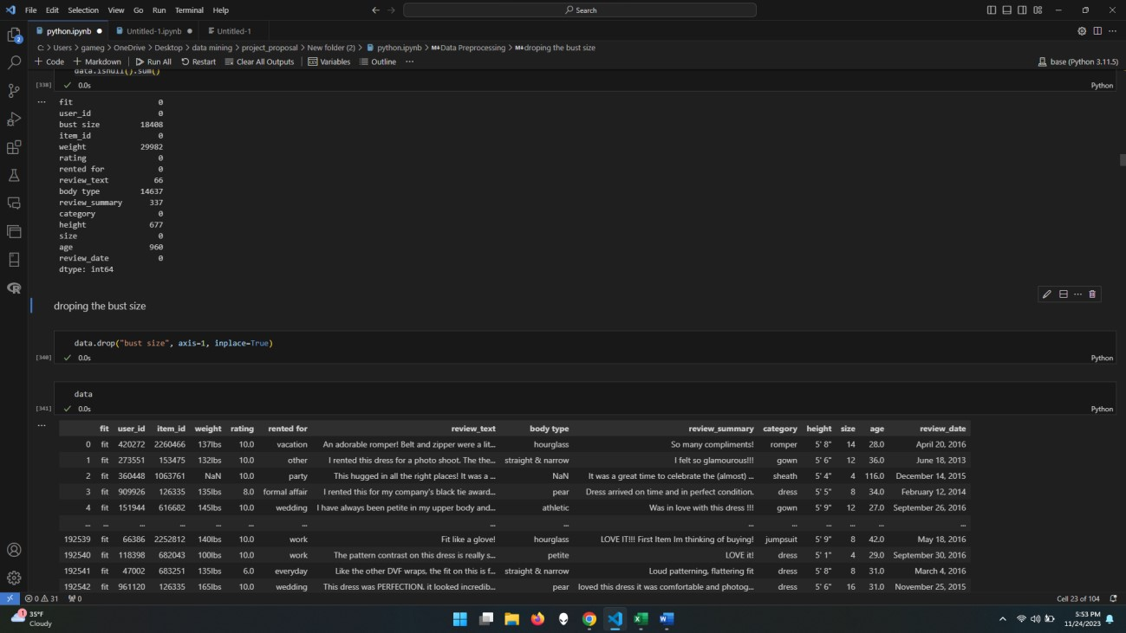

* As per our understanding, we are not going to use this column name (bust size) for our analysis, because we do not have any relevant information on that column & also there is 18408 null values for that column data.

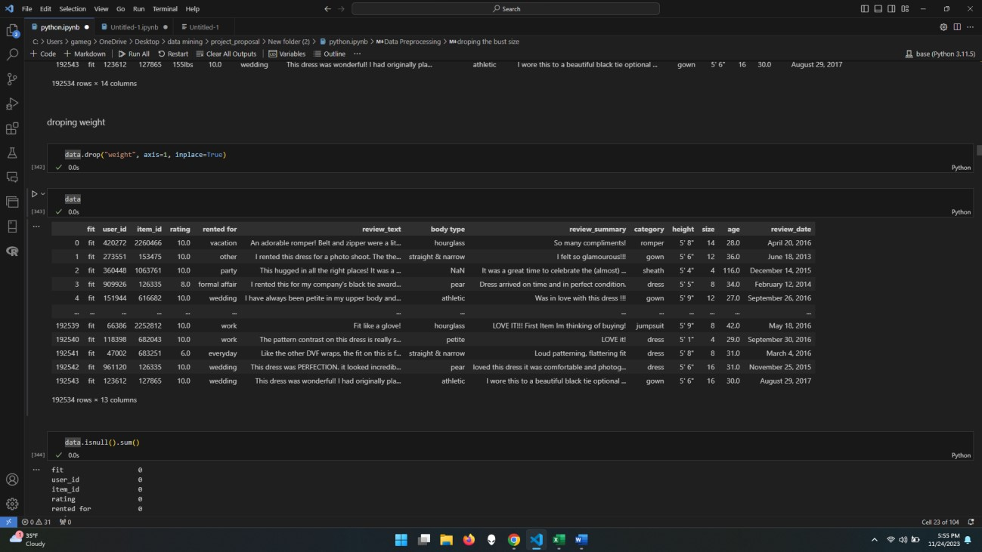

* As we get to know some values are subjective and different from humans to humans, we think, weight is one of those categories. So, getting the mean values of that column and considering that some humans have same amount of weight is approximate, because of that reason, we decided to drop null values of that weight row data.

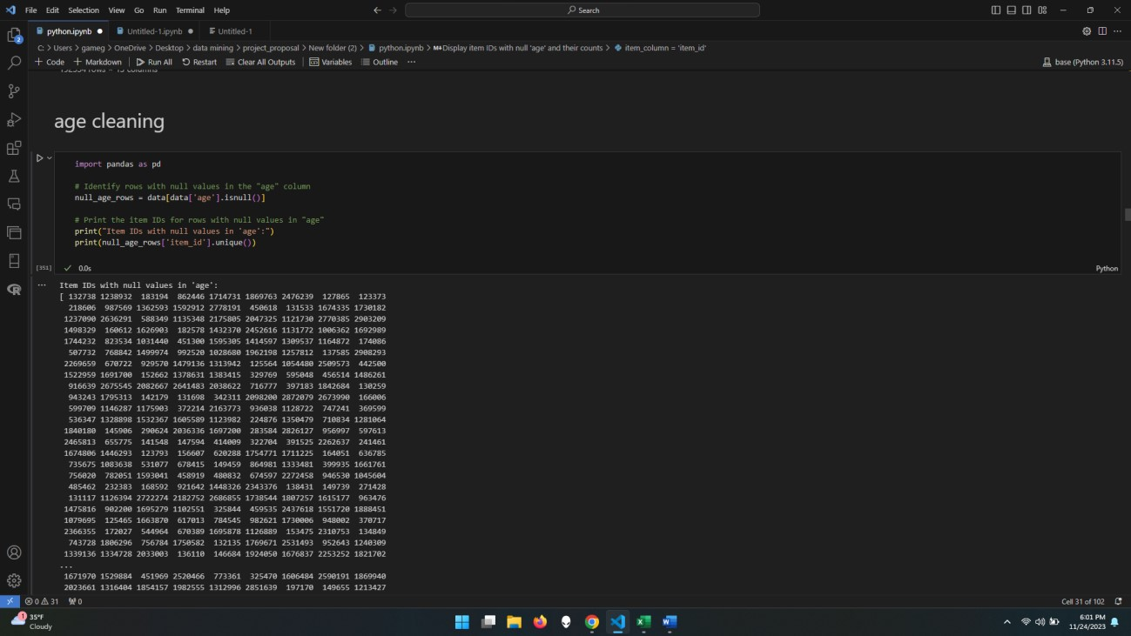

* Getting those item_id, which ‘age’ column name has the null values in the dataset.

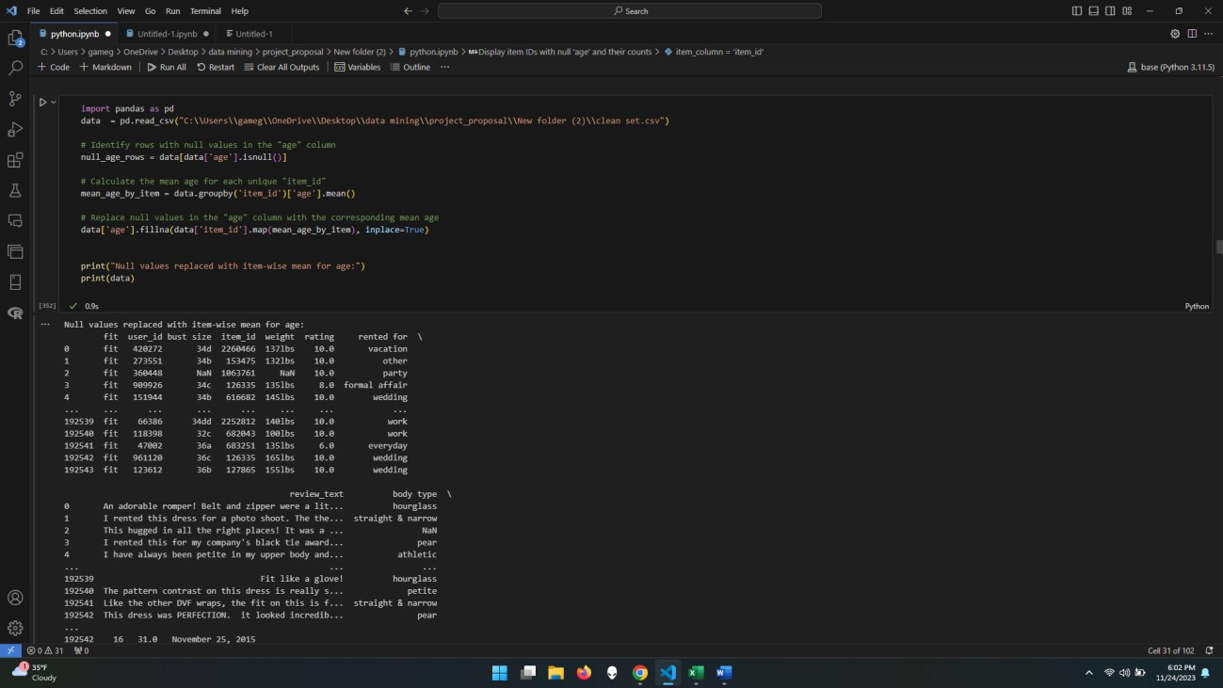

* So, as we get too many item_ids, we decided to select by the code and not manually and we selected the item and replace the values with a mean of that item_ids of age columns.

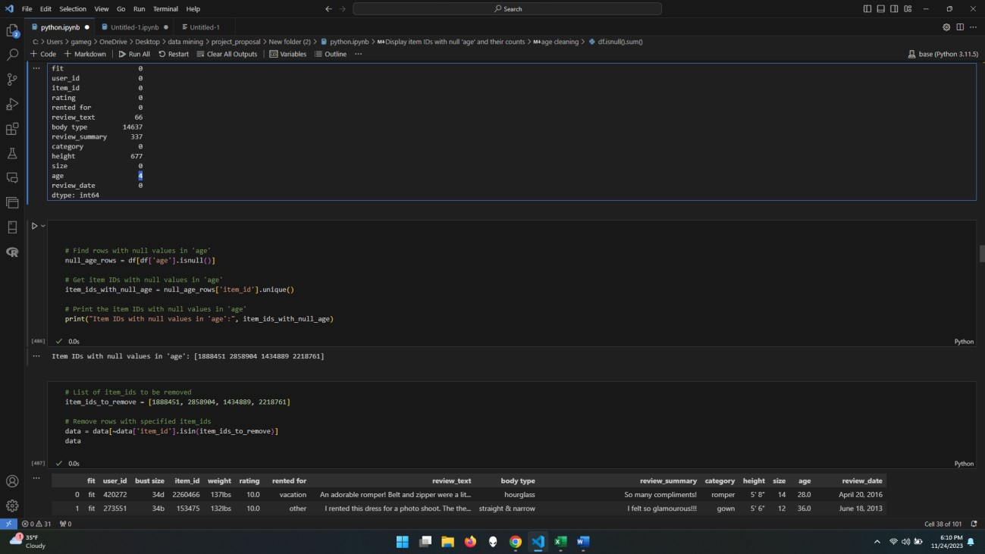

* Here, we get one problem, where after removing all null values, we get the 4 null columns, so what can be the reason that each item is unique and there are no values on that column.
* So, we removed those null value rows in that column in dataset with their item_id.

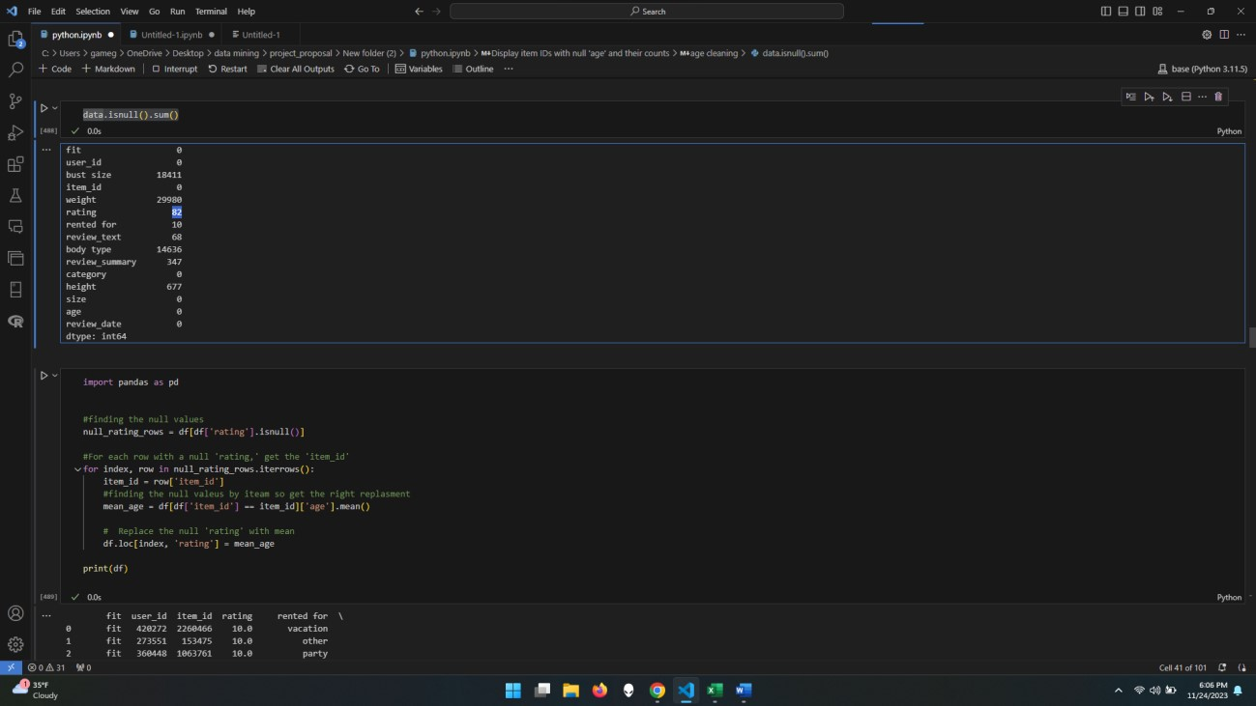

* Now we are solving the problem with the rating, and it has 82 null values
* So, we get the mean of each item to vise for the rating and replace that with the null values. And check that we do not have any remaining null vales on that

**Cleaning of Rating:**

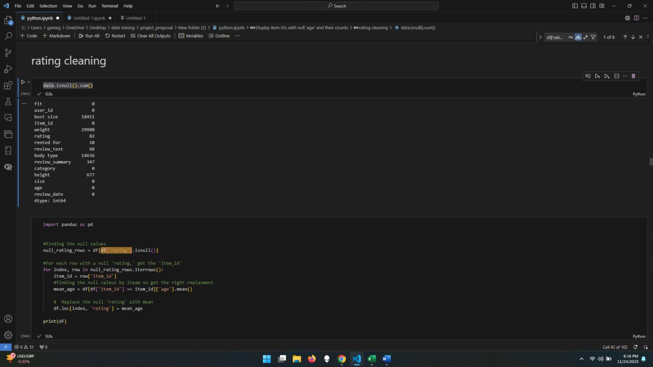

* Here we use the same method where we get the null values and their item IDs and using that we can find the mean of each item_id for rating columns and replace that with the null.

**Below are the reasons:** Removing the null rows from dataset that we cannot replace that with mean data.

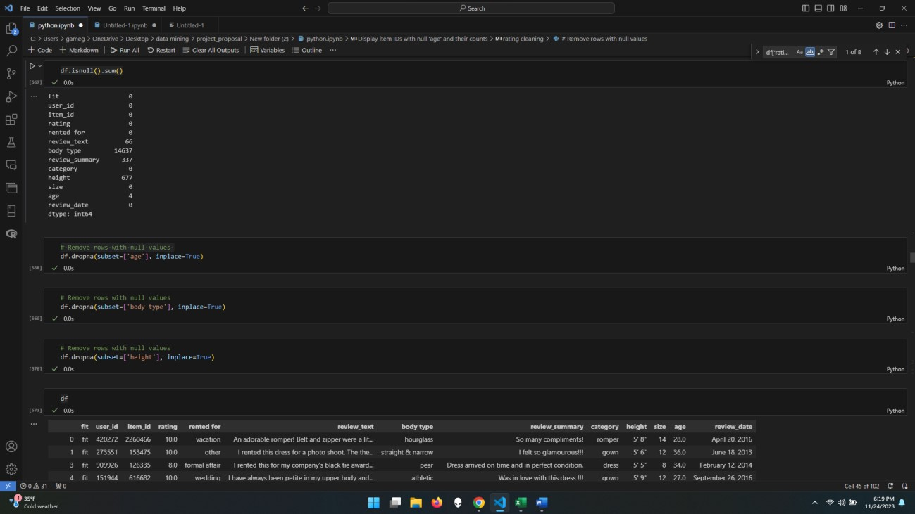

**For age:**

we do not get any value to find the mean of that column name ‘age’ because of that we have to remove those missing rows.

**For Body-type:**

It has text data, and it has many different answers, we replace that answer in numeric form, then it will give the float values. So, replacing that with numeric values to find the mean of each item also we must replace that numeric values in text to represent the nearest body-type, and it is not possible, because we could get the wrong output at the end.

**Example:**

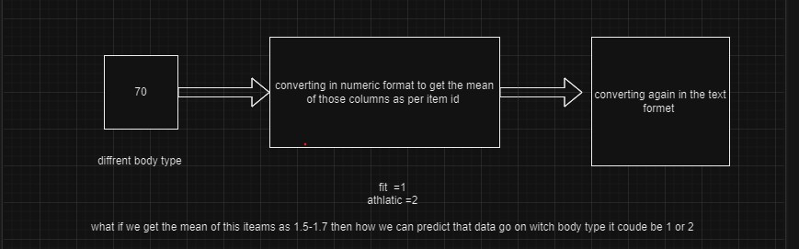

Also, it is highly dependent on a person's age, height, weight, and also how their lifestyle is. so, it could be a wrong prediction with this amount of data.

**Height:**

It is hard to replace that with actual data because we have got 677 missing values in that replacing that could be different for the size of the user's dress and fitting of that dress, So, that might be not alien to the other data.

**Review text:**

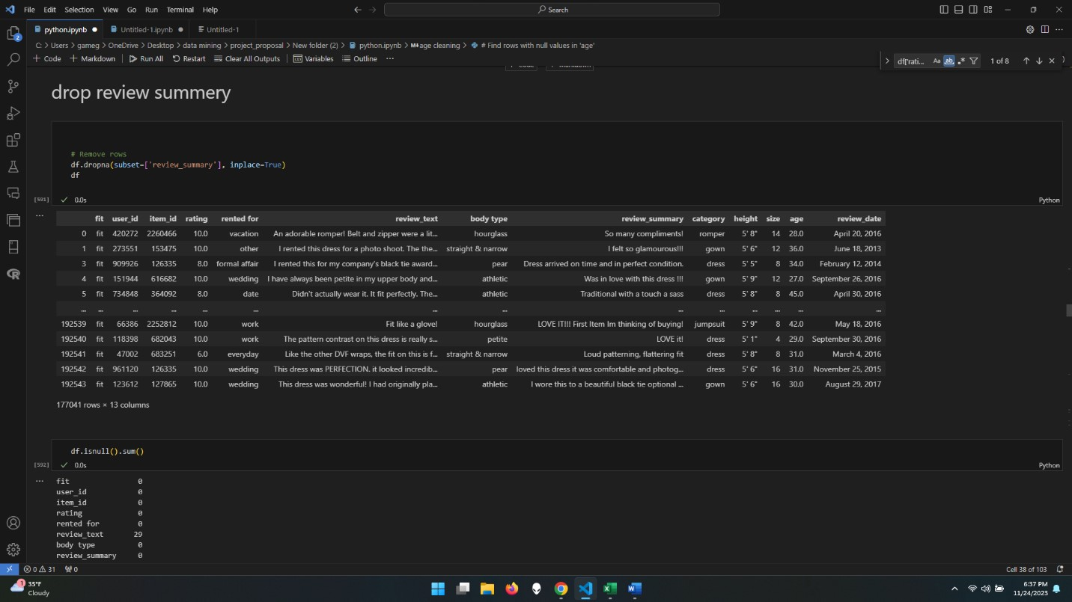

* Removing review_summary all missing values row data from the dataset, because we cannot replace that with anything. We are only removing noisy data, which is not useful in missing values for our dataset and for our model also. And we are not dropping whole columns.

**No null values in the data, so now we can start the text-cleaning:**

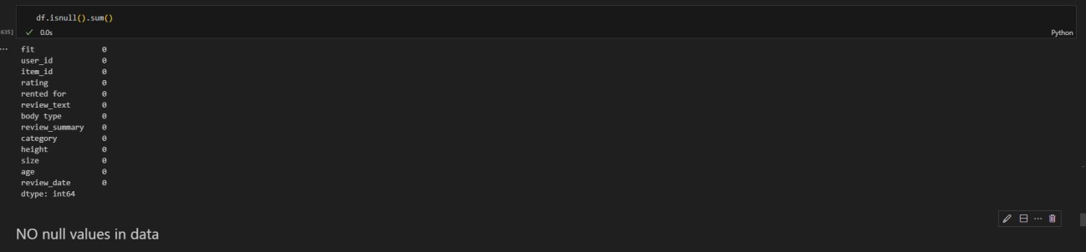

* Now identify the categorical data and replace their types as categorical. So, we can easily use that data for the machine learning models.

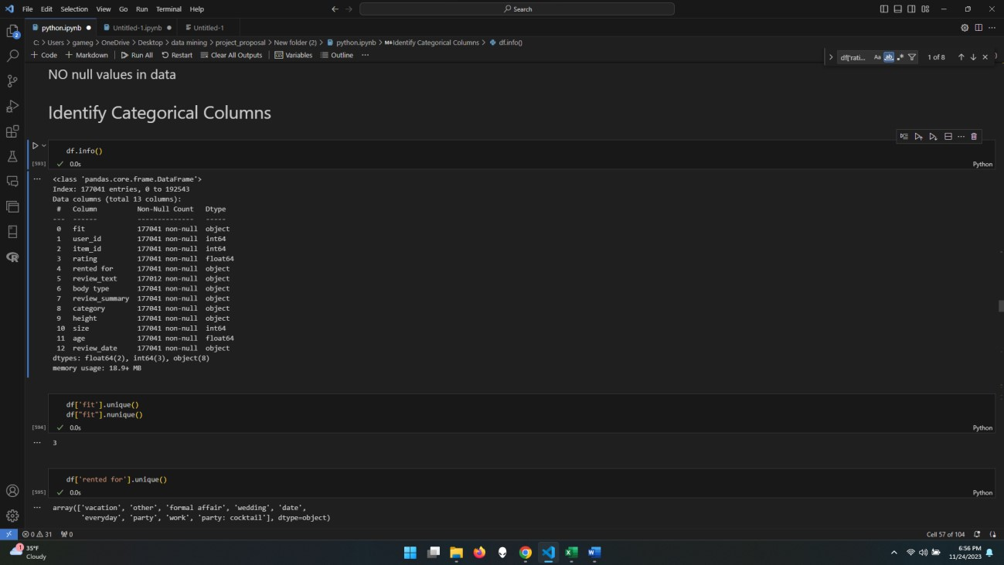

Now finding the data variations and reducing that for further understanding and text analysis:

**Finding the z-score and IQR for columns:**

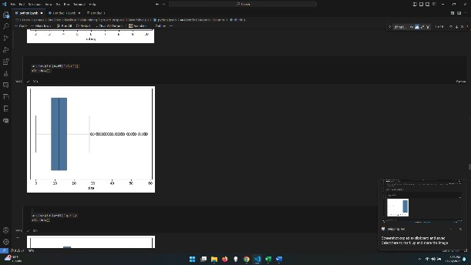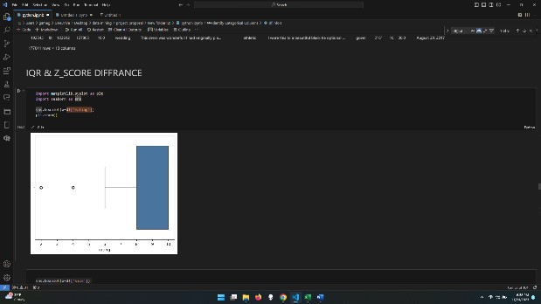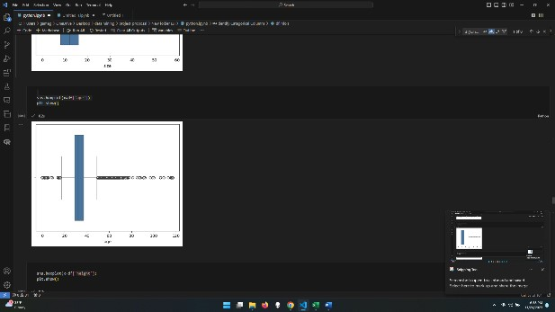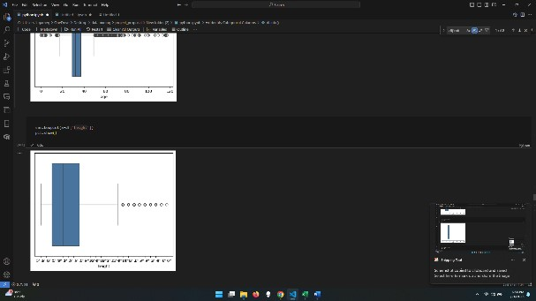

* Now after applying z-score and IQR. Next, we will perform the minimizer and remove the anomaly from the data, which was very noisy data that had to be removed.

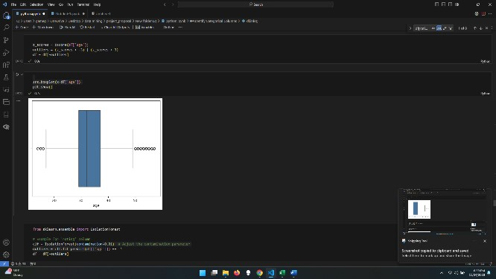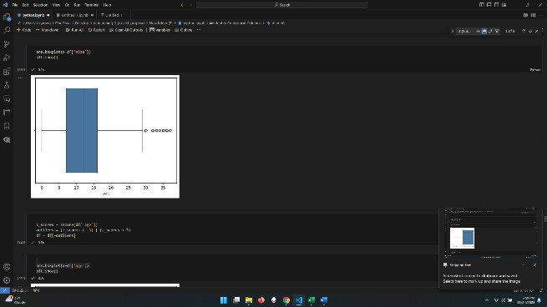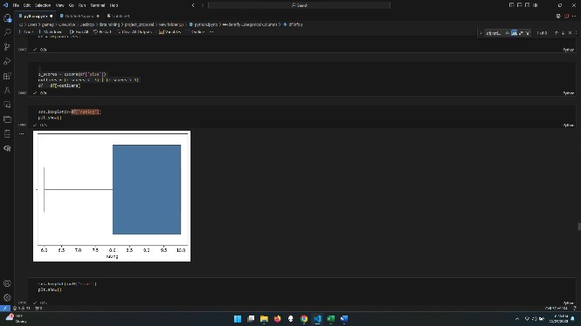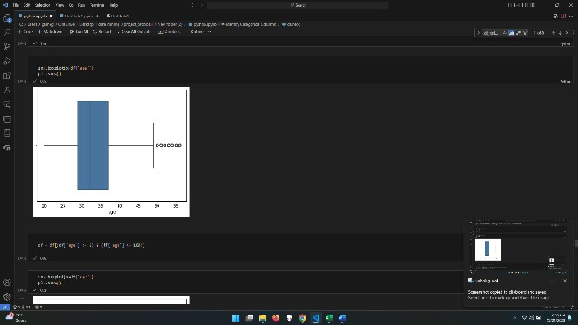

**Text cleaning: below is the text cleaning process**

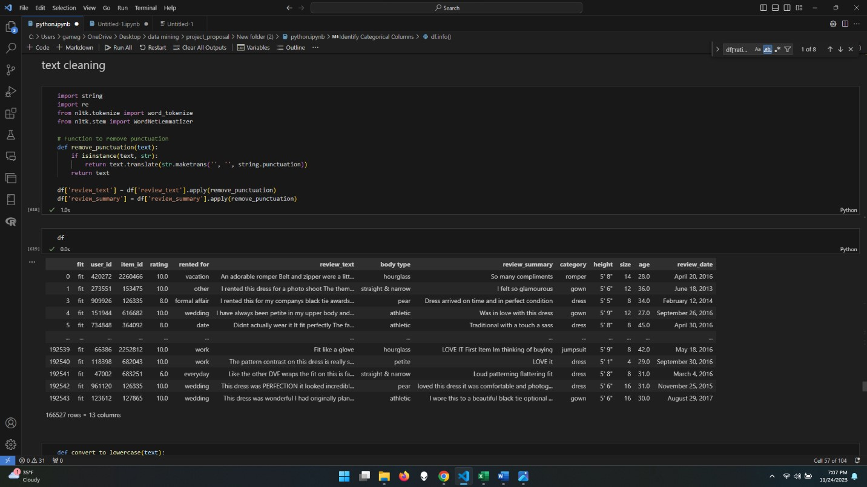

* Here we are removing the punctuation from the text data and making it usable.

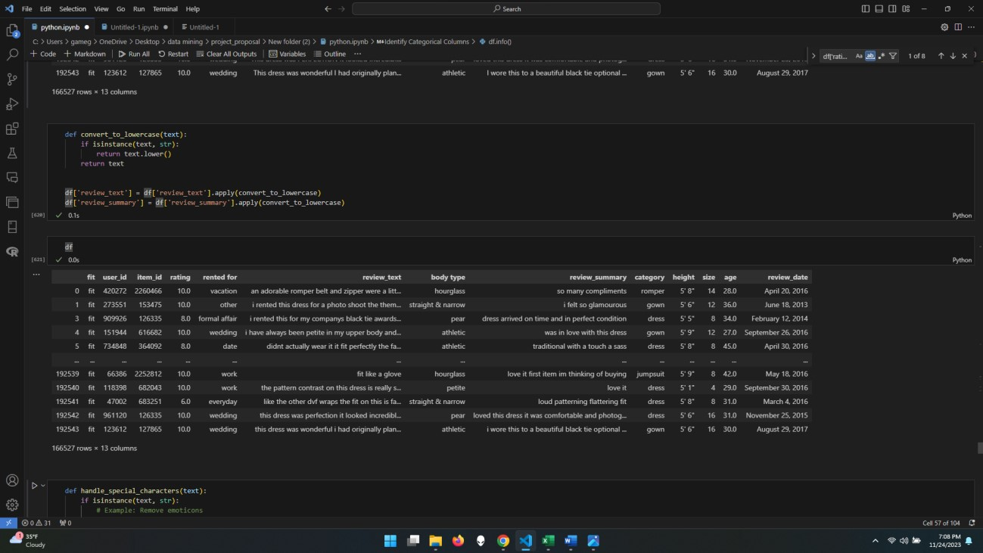

* Now we perform converting our text data into lowercase format. So, we can easily understand and do further text analysis.

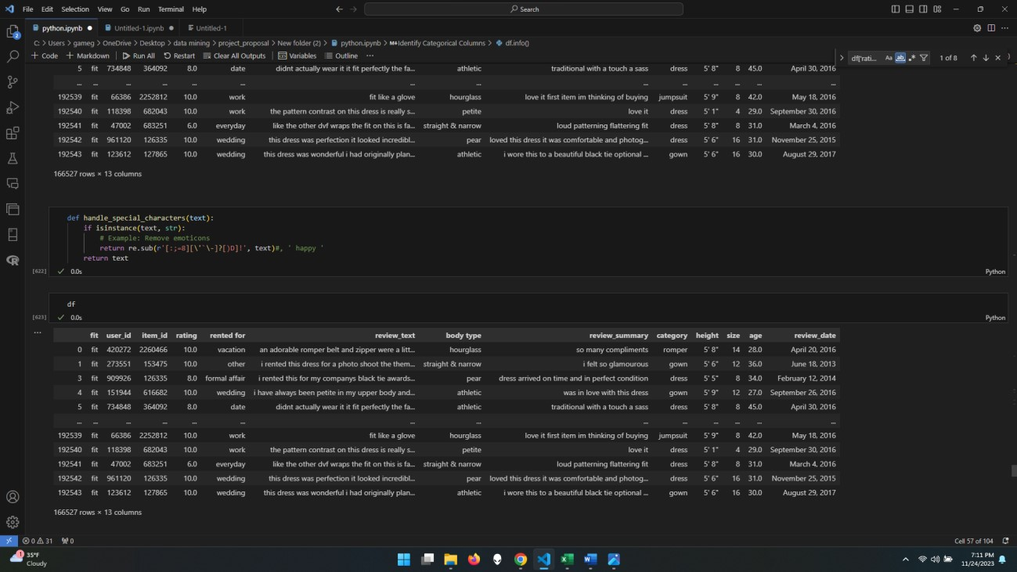

* Also, it is very important to remove special characters from the data. To use this text data for further text analysis because having special characters might give you some errors in data understanding.

**Tokenization:**

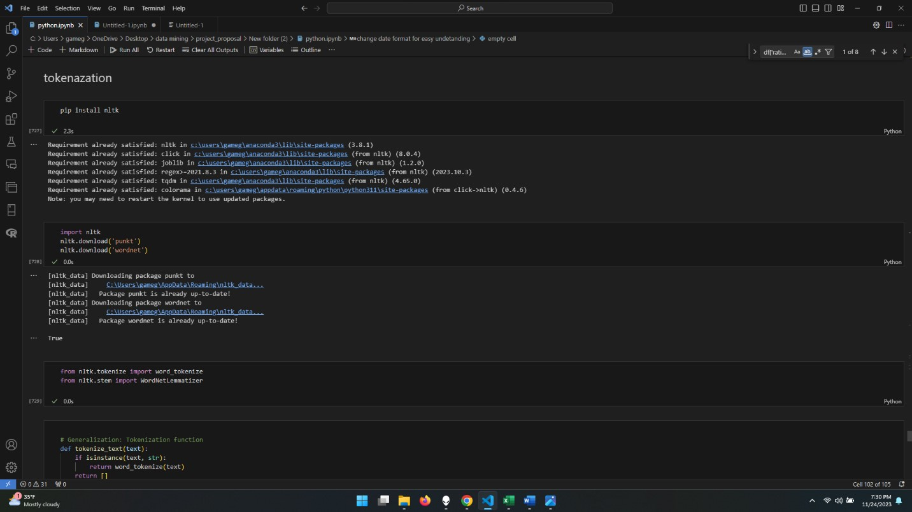

* Firstly, Adding the required library for that then importing that library.

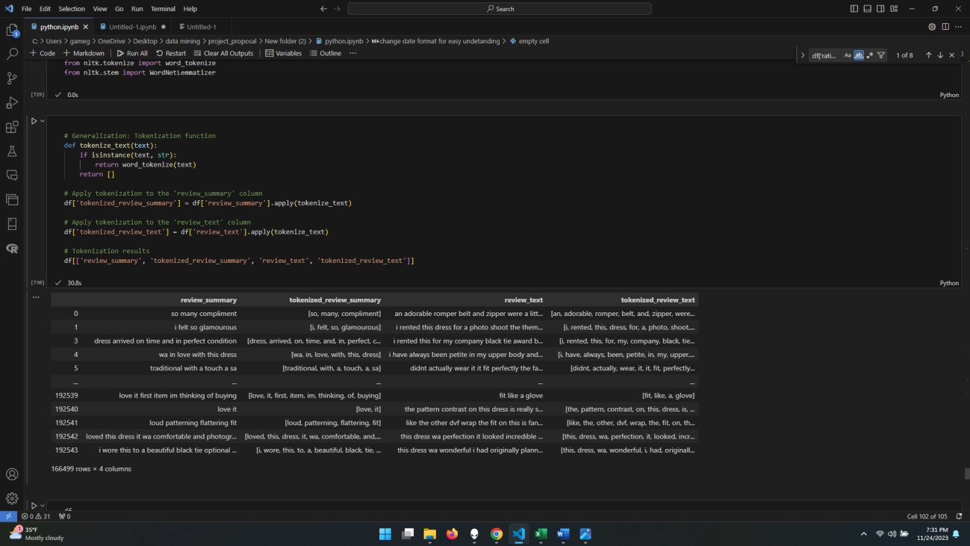

* Now we did the tokenization on the ‘review_summary’ and ‘review text’. so, our data is ready for the text analysis.

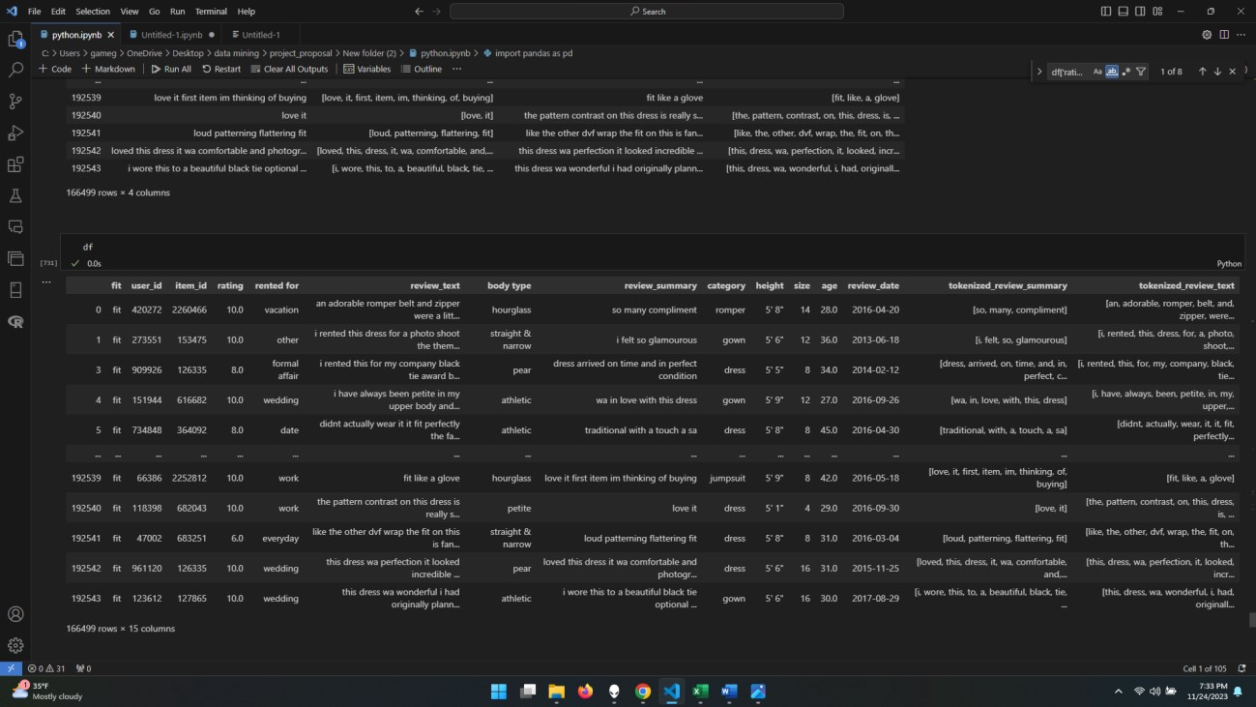

* Now added those columns in my dataset for with names of **tokenized_review_summary tokenized_review_text**

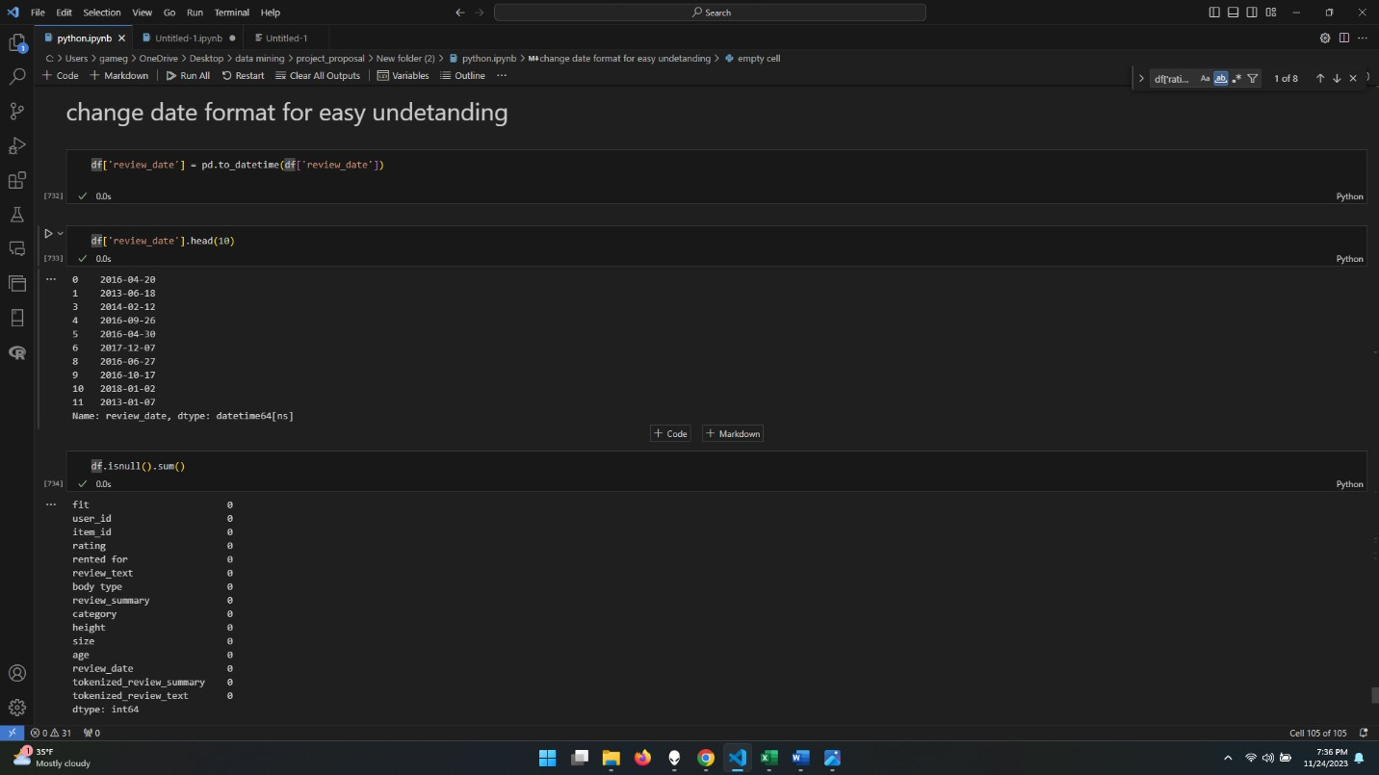

* Changing the date format, because we have some dates with month names, and it is not appropriate format, so making it every date in one format.

**Now we starting from here, File name: (Untitled-1. Ipynb)**

Here we are calling our csv file with name of java.csv   
our main goal for file is finding the word cloud and if we can find any relation base on that

To perform the recommendations based on rating.

* Now you will see we performed Stop-words and wordnet.
* List of tokens.
* Some filtered words to performed on review_text.
* Will apply the tokenize clean and lemmatize function.
* Will see using Word-cloud on recommendations which we found from rating.
  1. To add new column recommendations based on rating:
     1. 0 = ( <7 )and 1 =( >7 )
* Here, we are showing that we applying Lamba Function to create a new data frame(df) for recommendation base on our dataset’s Rating column.

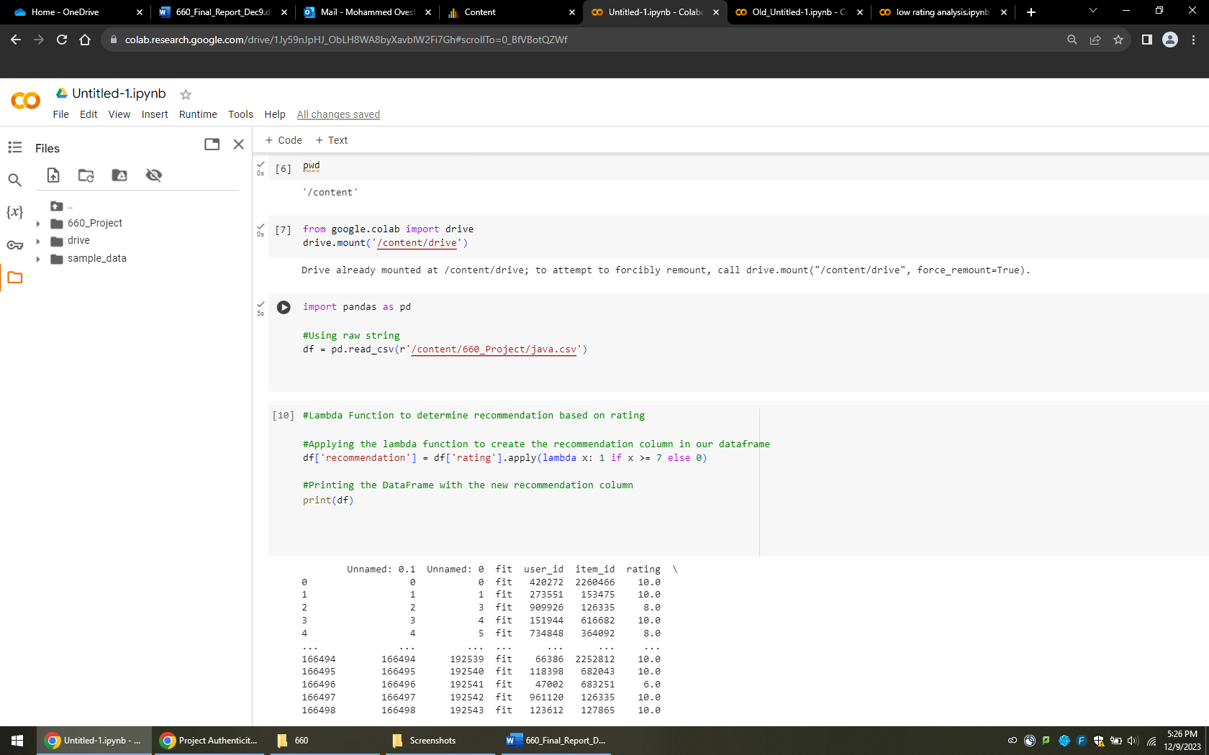

* Below is the Output that shows column of Recommendation.

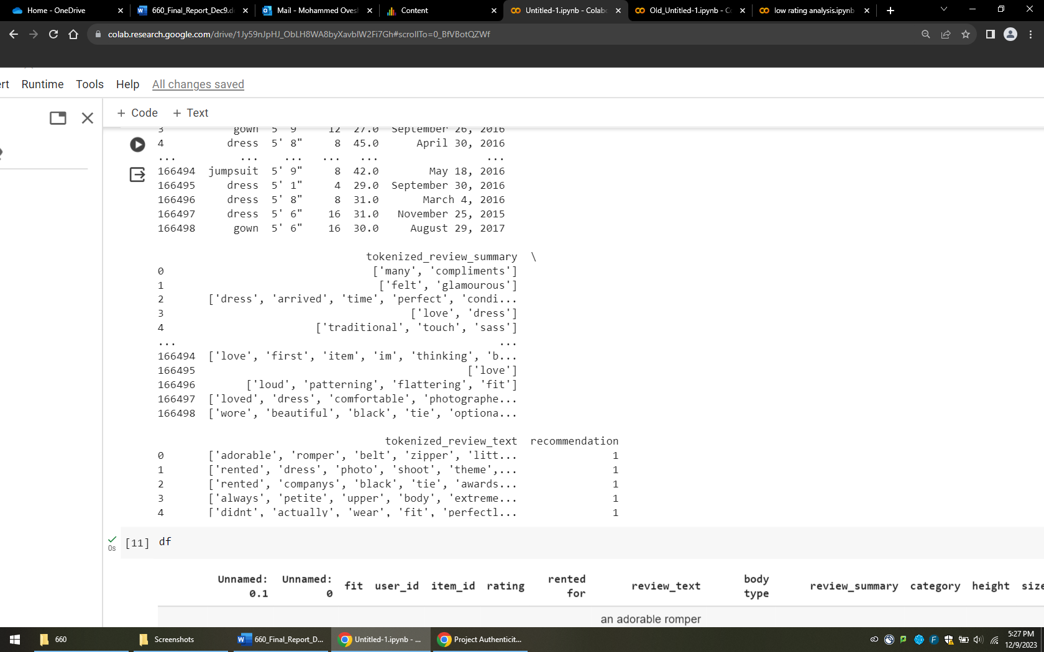

* 1. Now you will see we performed Stop-words and wordnet: -

Explanation:

* Here, we downloaded nltk and imported stop-words and wordnet-Lemmatizer.
* We have removed punctuations using string punctuation on the content.
* Performed text into lowercase and removed some stop-words on review_text. And showing the new column creating as ‘cleaned_tokens_lemmatized’.

Now it shows the pie chart of rating and variations of this.

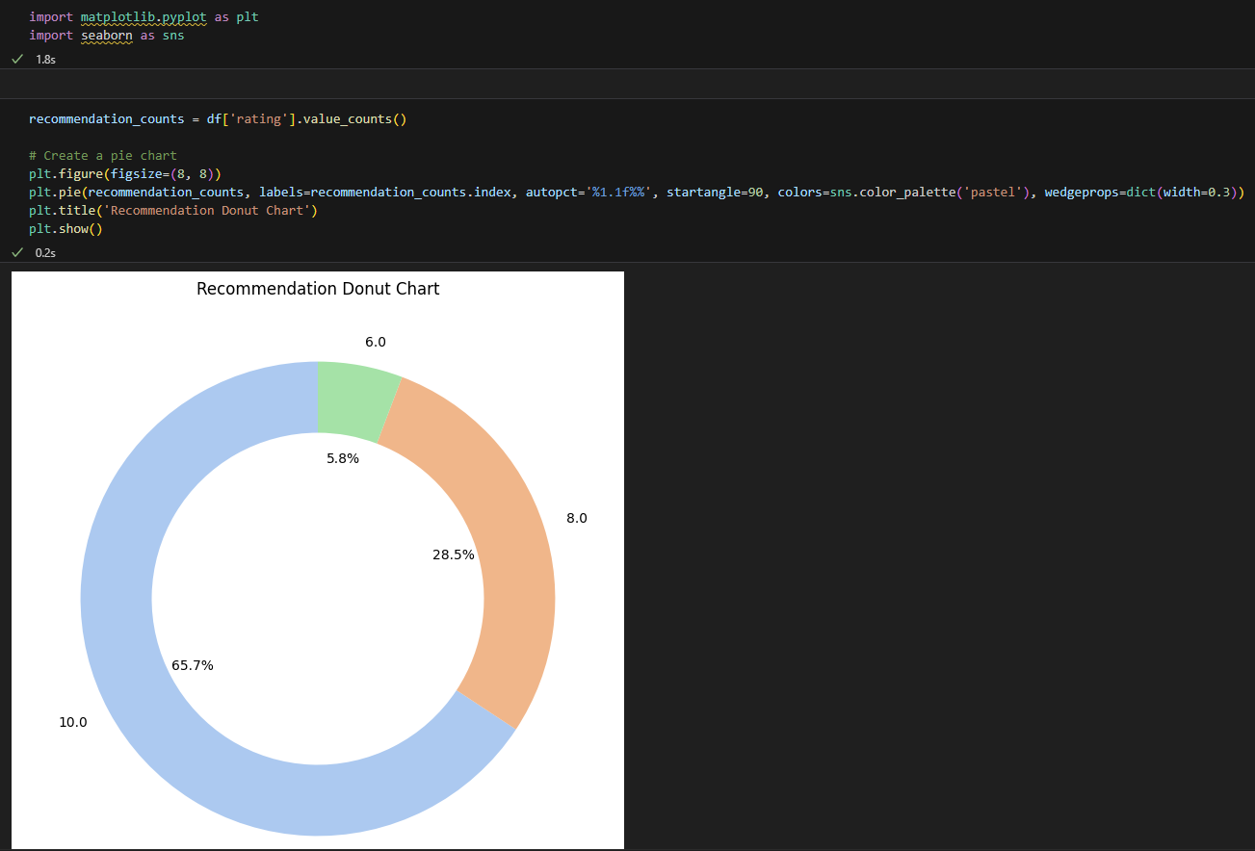

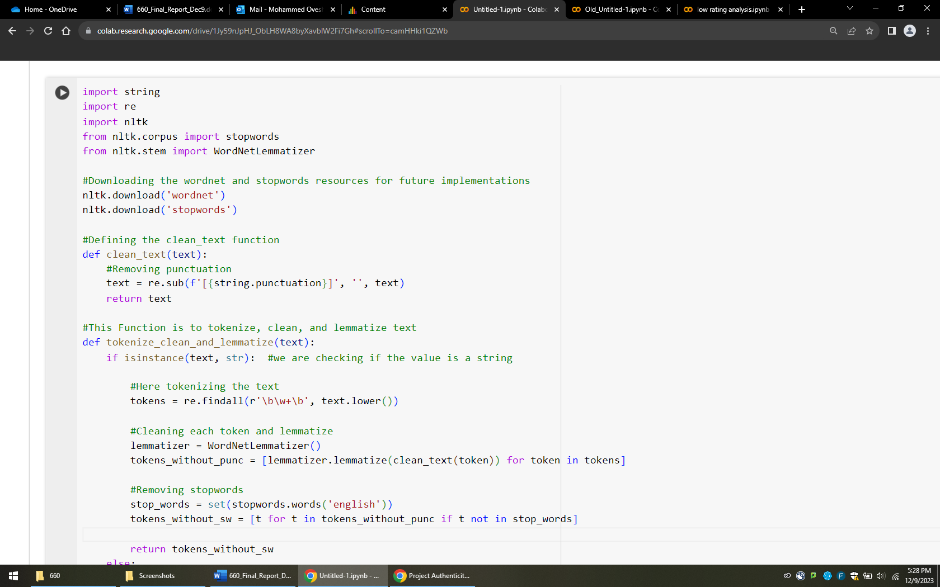

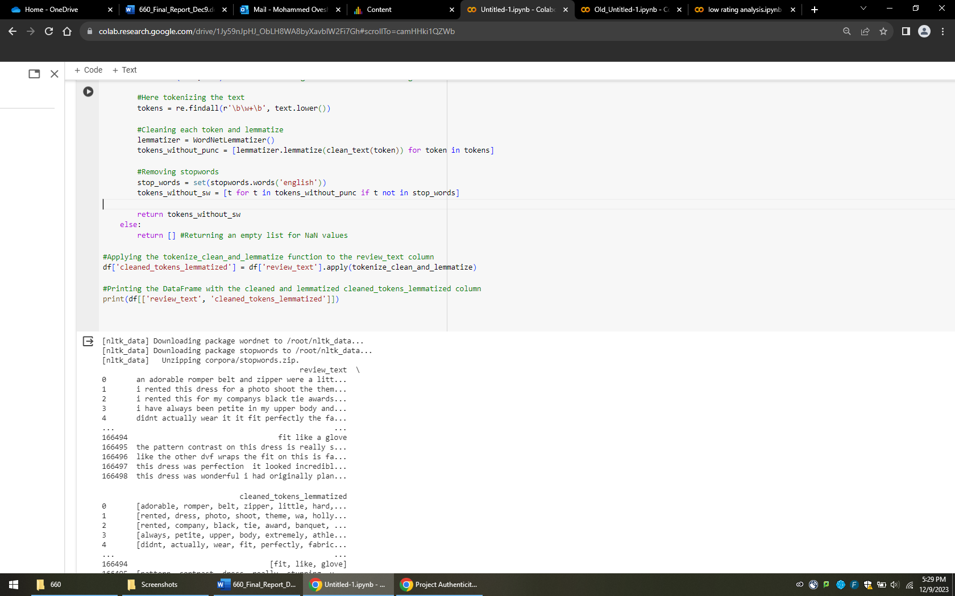

* Here we are showing the proper output of our data-frame with updated columns.

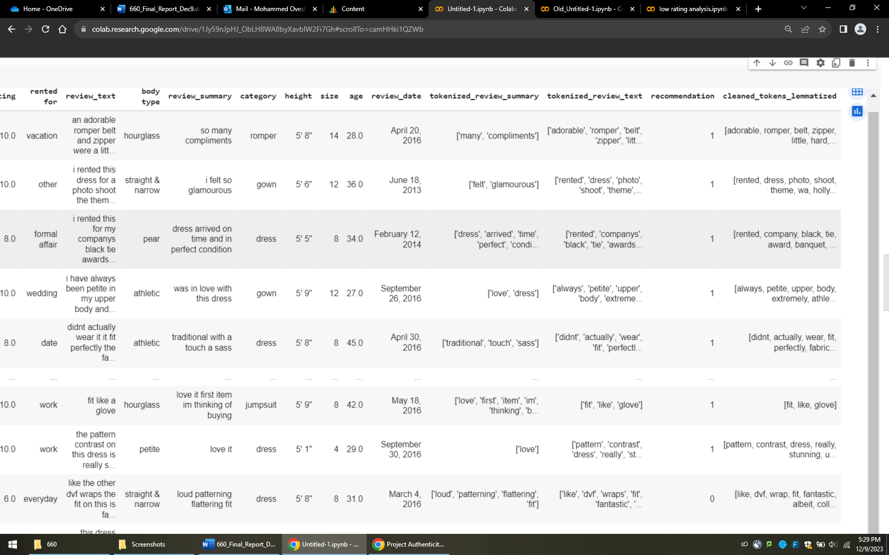

* 1. List of Tokens:
* First of all, ‘flat_tokens_list’ This line of code is for comprehension to flatten a list of lists. And as we took each sub-list from ‘cleaned_tokens_lemmatized’.
* After that, we are joining those tokens strings and then Splitting those joined tokens strings.
* Using print to prints first 100 tokens from the list.

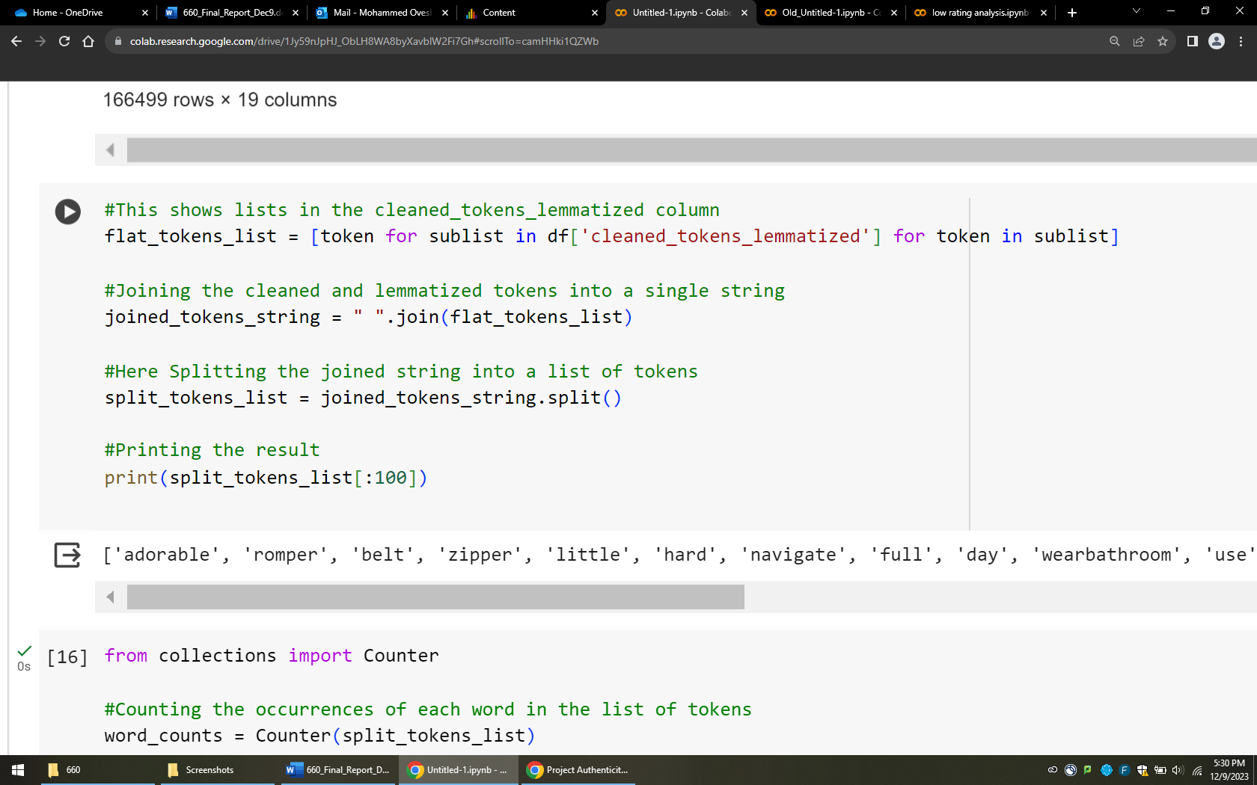

* It shows the words which is separated from one by one to find the reputation on that or count of each word .
  1. Filtered words to performed on review_text:
* Now find the word count of each word and make see that we have the many words with major reputation however some words are not repeated that much so we can remove those words and we remove that words from out data and save new file
* There is filtered words line that creates new list, and it performed items (word, count) an object and taking only those words which is greater or equal to 2.

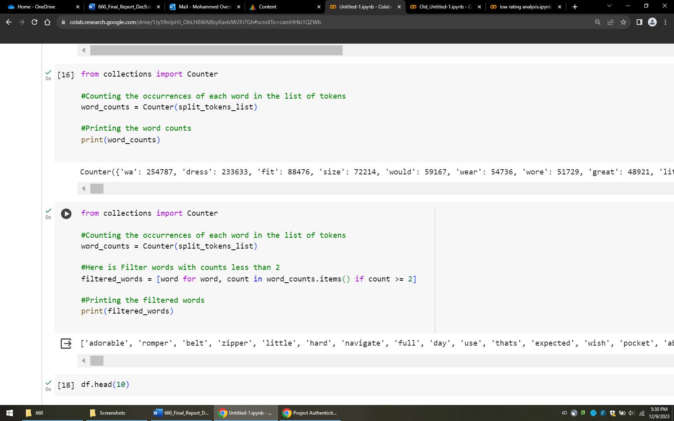

* Showing data-frame of 10 line in below screenshot:

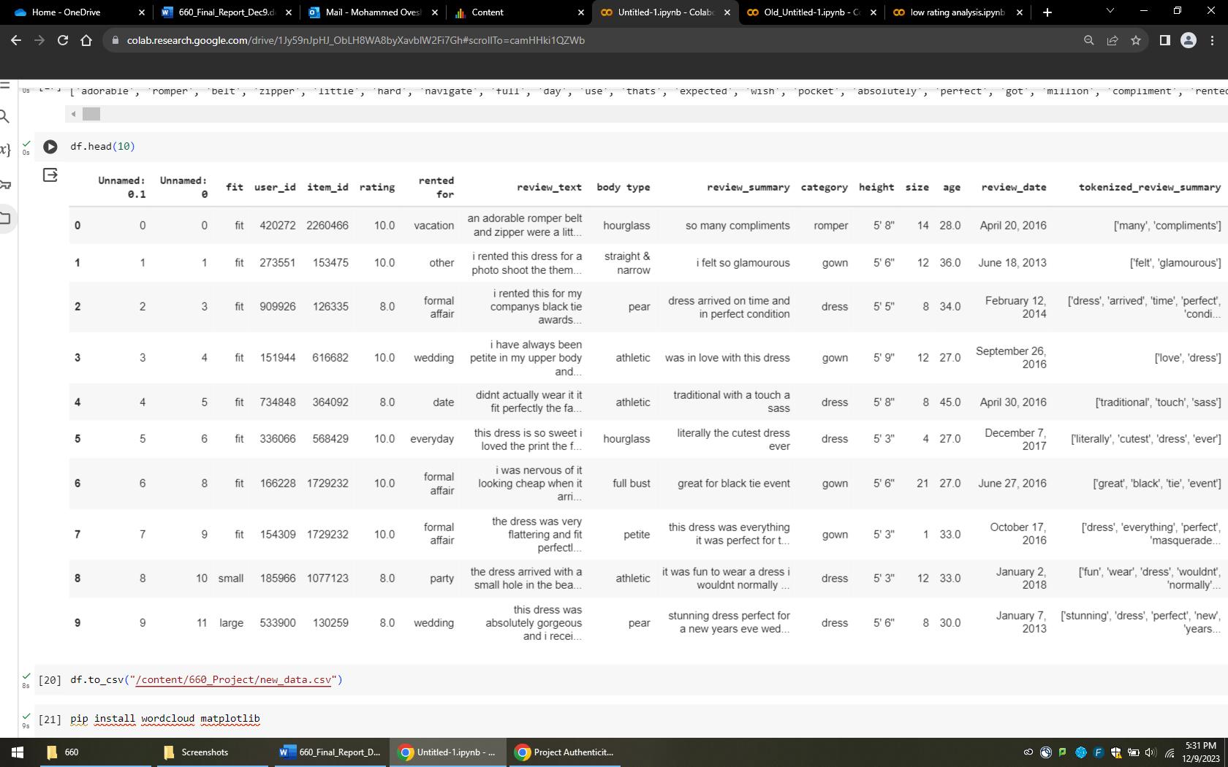

* Saving the file with name of new_data.csv and installing wordcloud matplotlib.

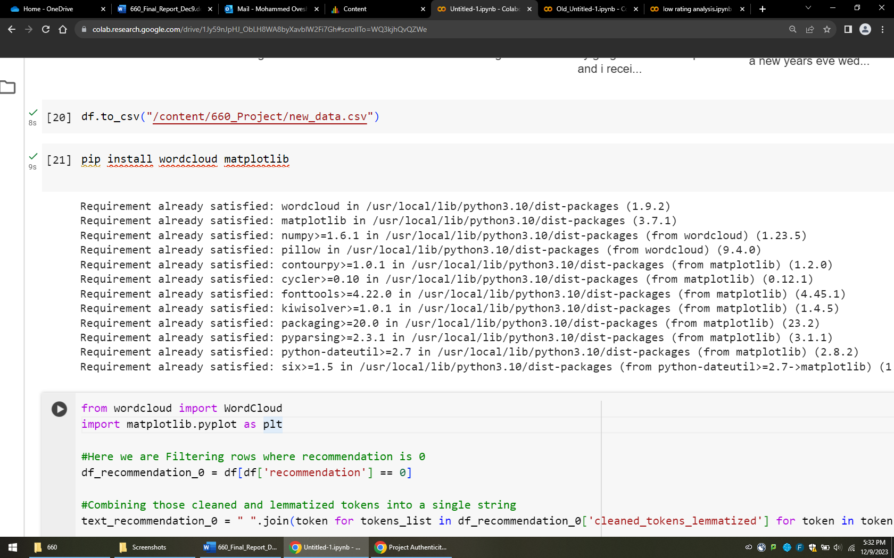

* 1. Word-cloud on recommendations which we found from rating and
* Here, we are generating word cloud from our clean and lemmatized tokens which we did before and filtering the rows for recommendation.
* Below is a code for recommendation for 0

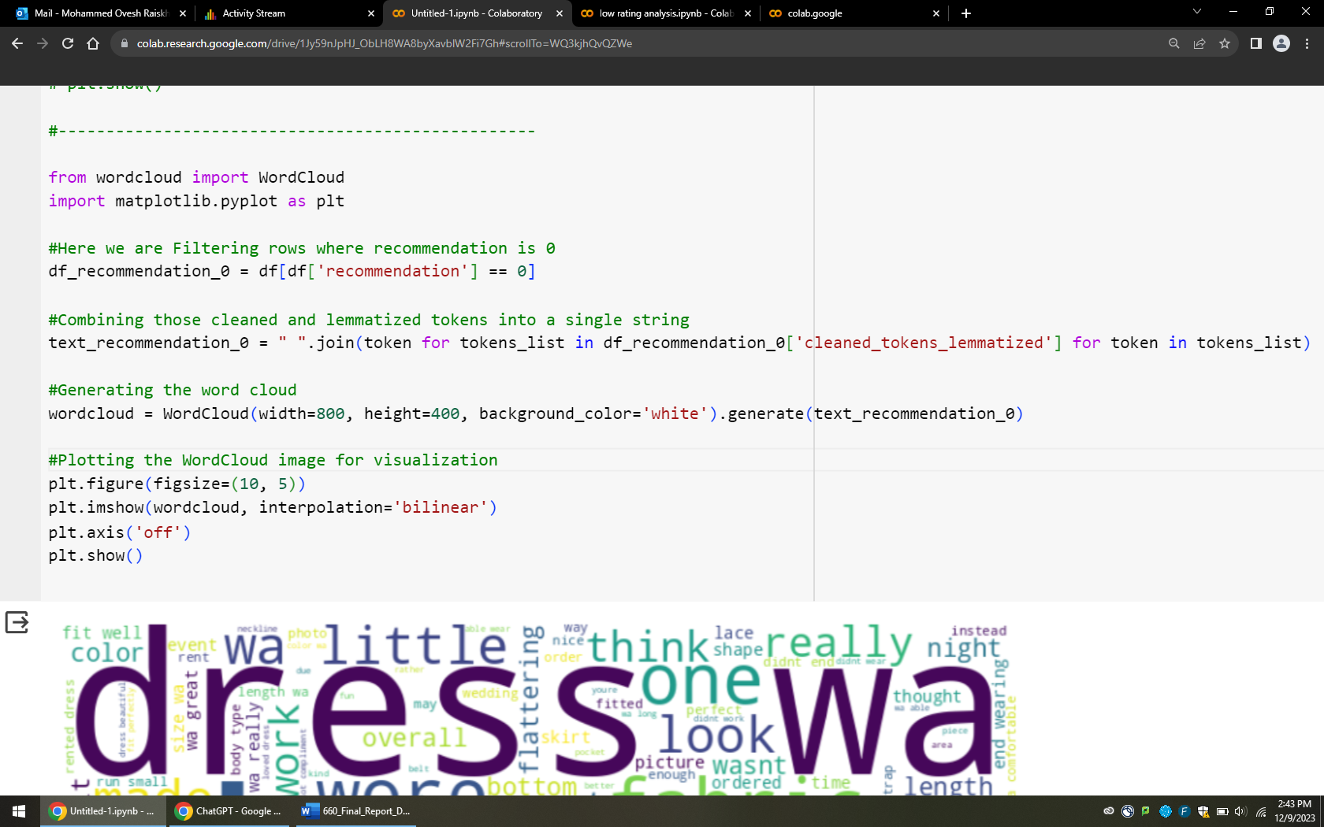

* Below is the Screenshot for recommendation 0 using wordcloud visualization using matplotlib.pyplot

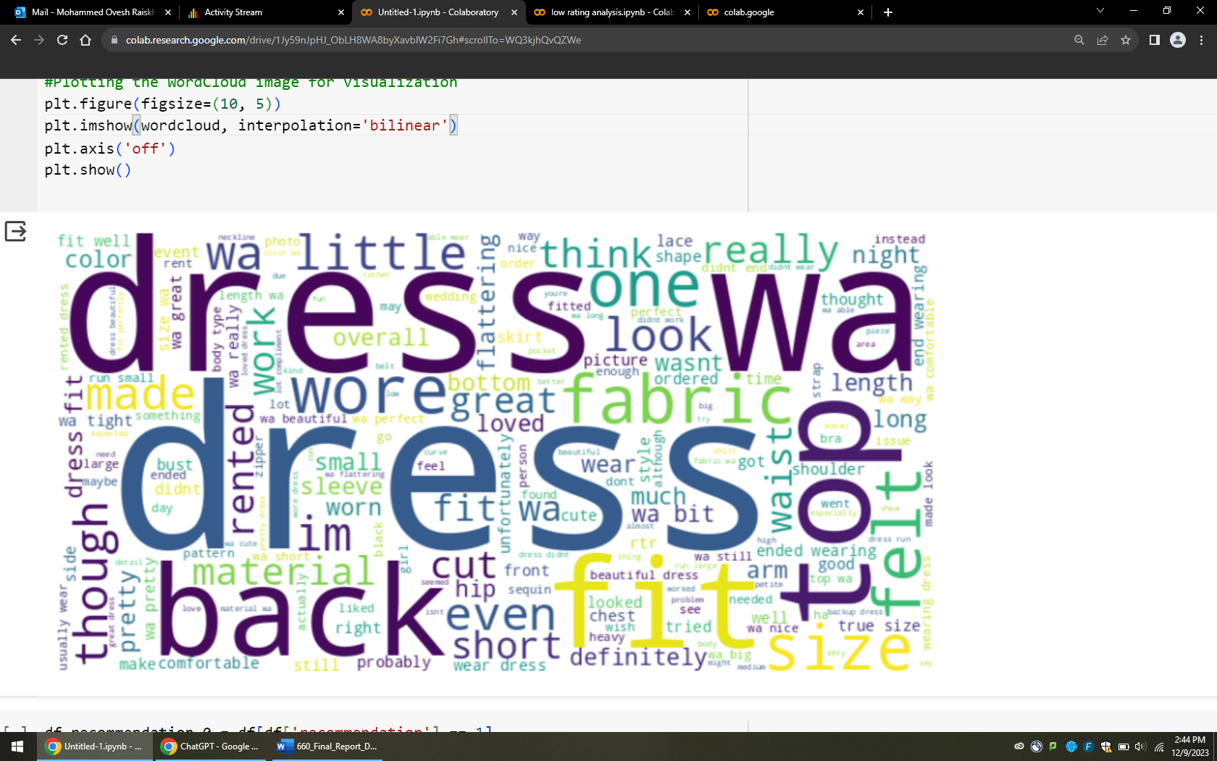

* Here we are performing same thing to build word cloud and visualization but this code is for recommendation 1.

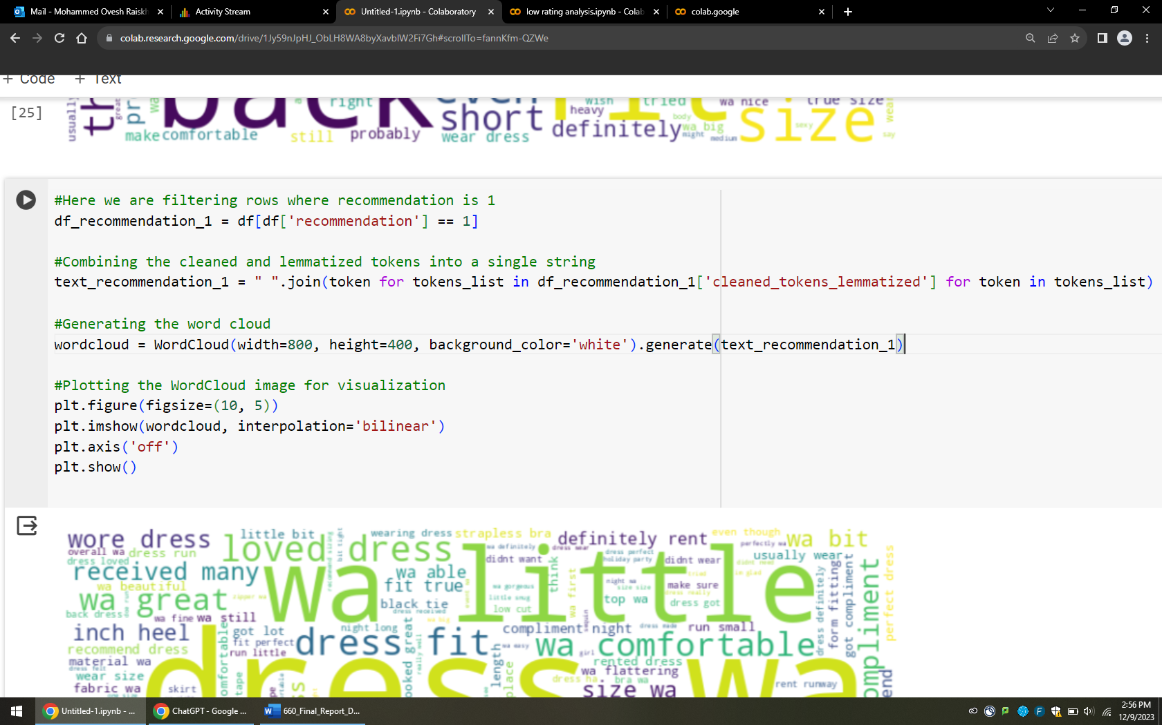

* Below is the Screenshot for recommendation 1 using wordcloud visualization using matplotlib.pyplot

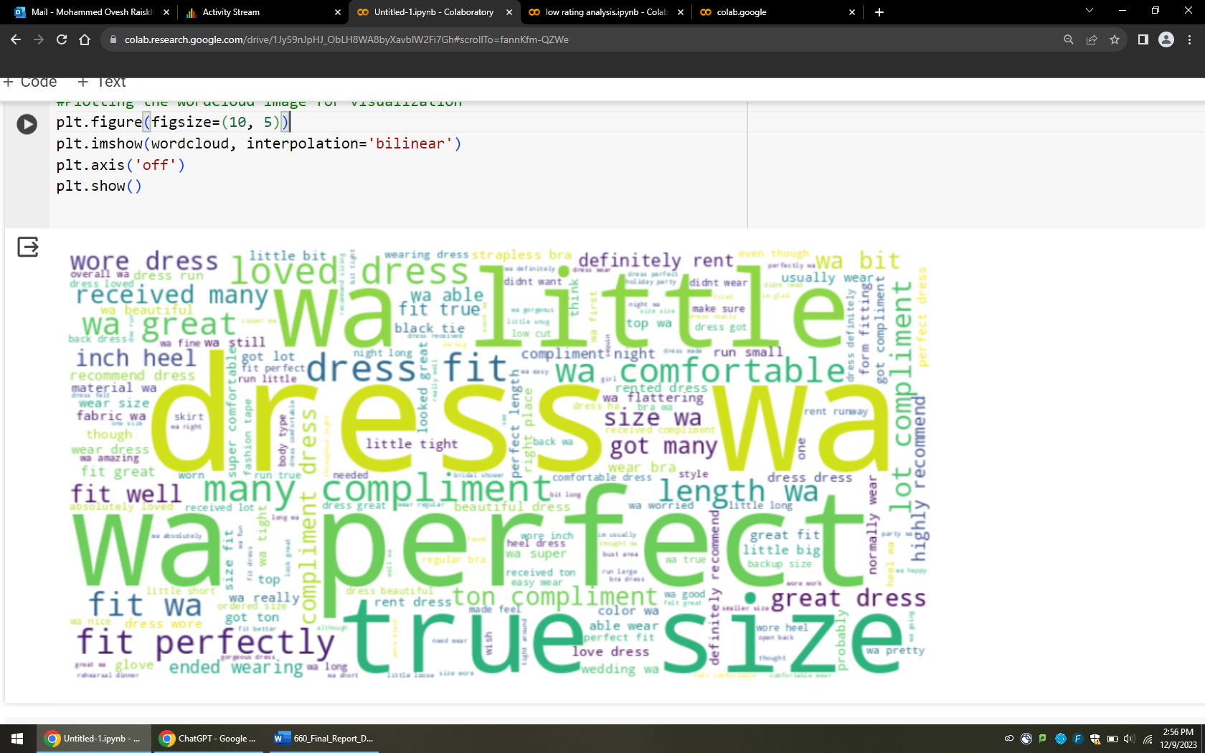

**Now we starting from here, File name: (Low rating analysis. ipynb)**

Here we are calling our csv file with name of problem_less rating.csv file

This file goal is seeing that how data is related with each other and how columns are connected.

* Will count the size of each element like age, rented for, size, user_id etc.
* Will plot a graph for age groups which includes dress, gown, sheath
* Will show pivot table

1. Importing the problem_less rating.csv and showing is there any null values present:

* After importing the file, then we have used these commands to check any missing values in our data-frame.
* **Command:** df.isnull().sum()

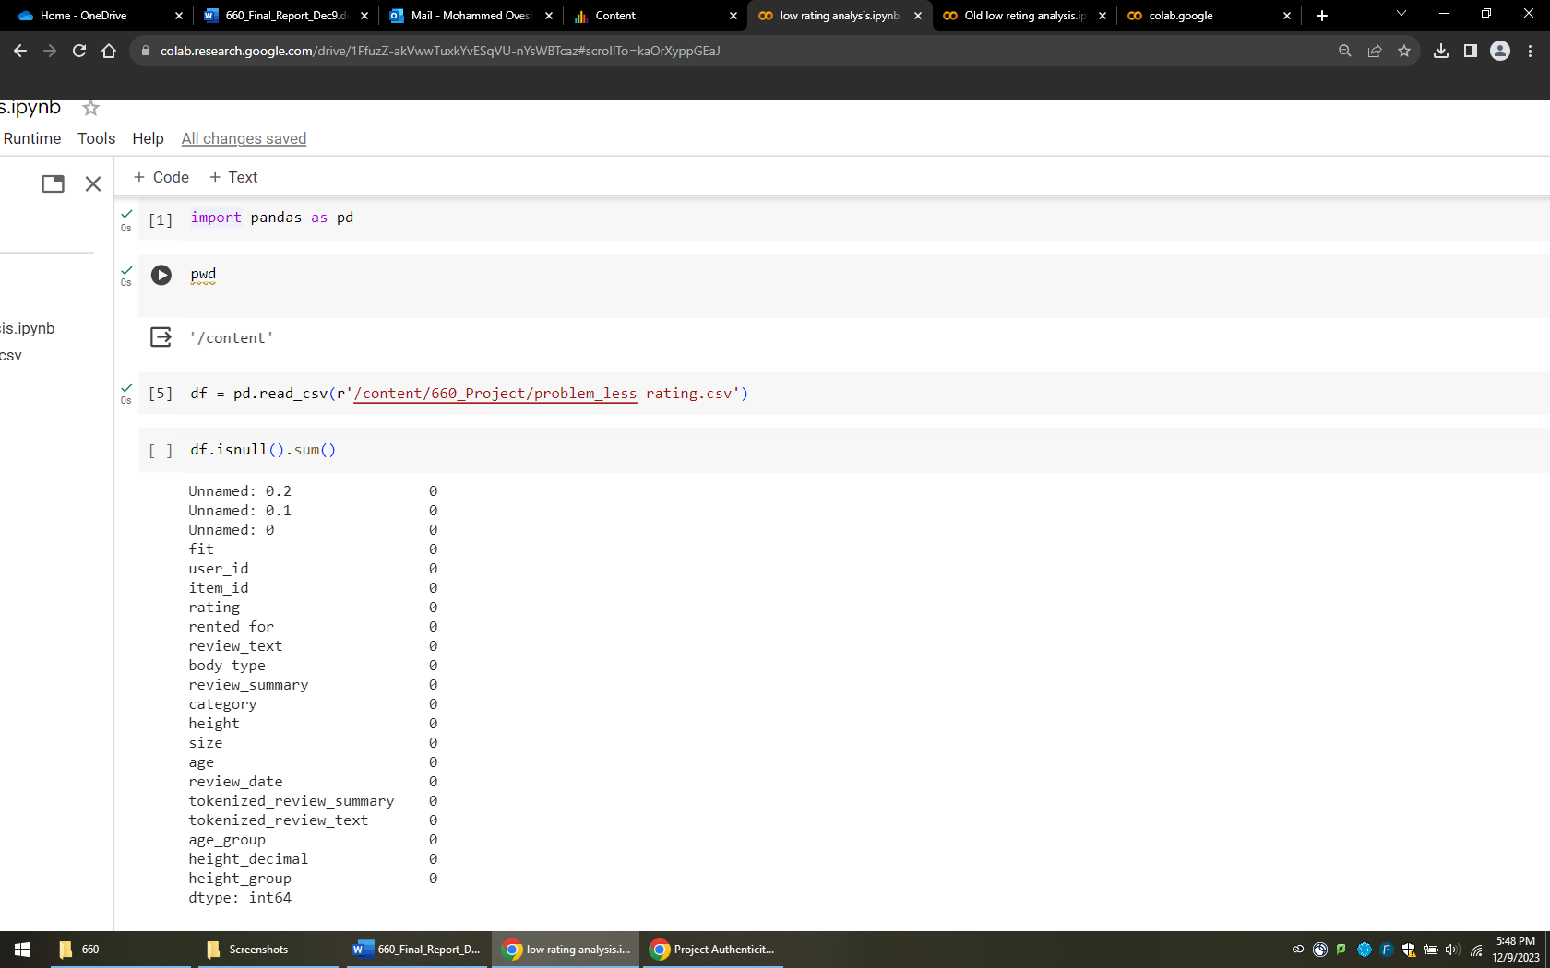

1. Showing the info:

* Showing our data information like Column, non-null count, and Dtype

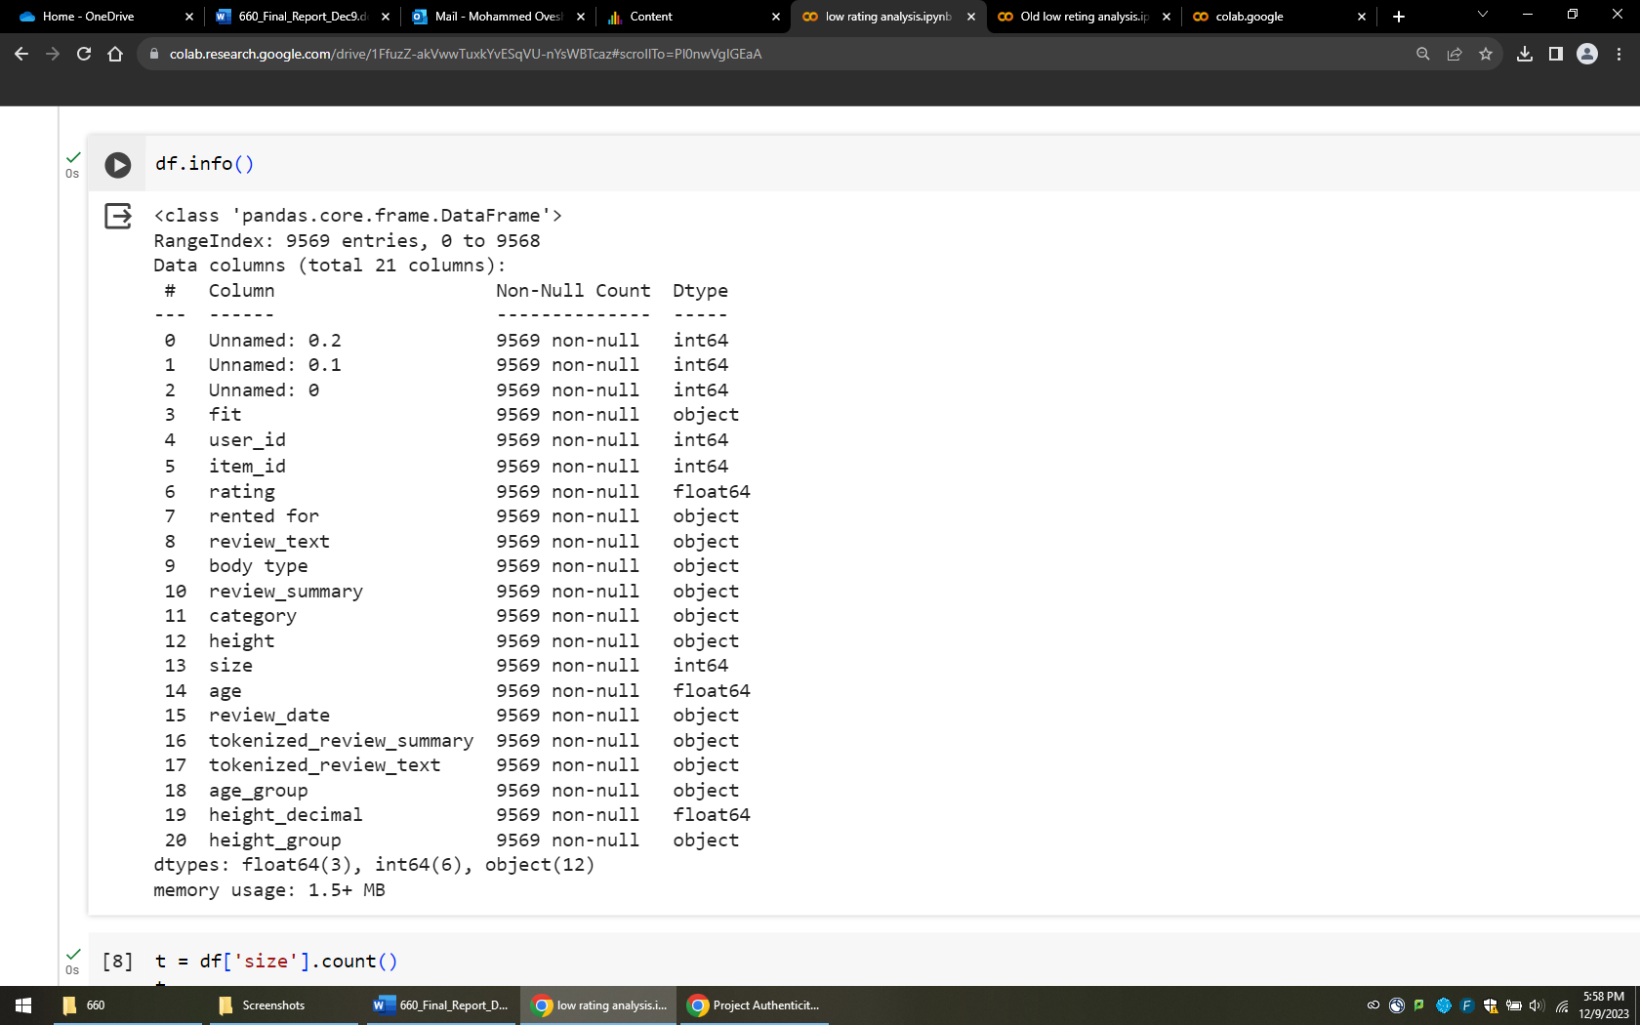

1. Showing each count of columns:

* Checking each column one by one count.

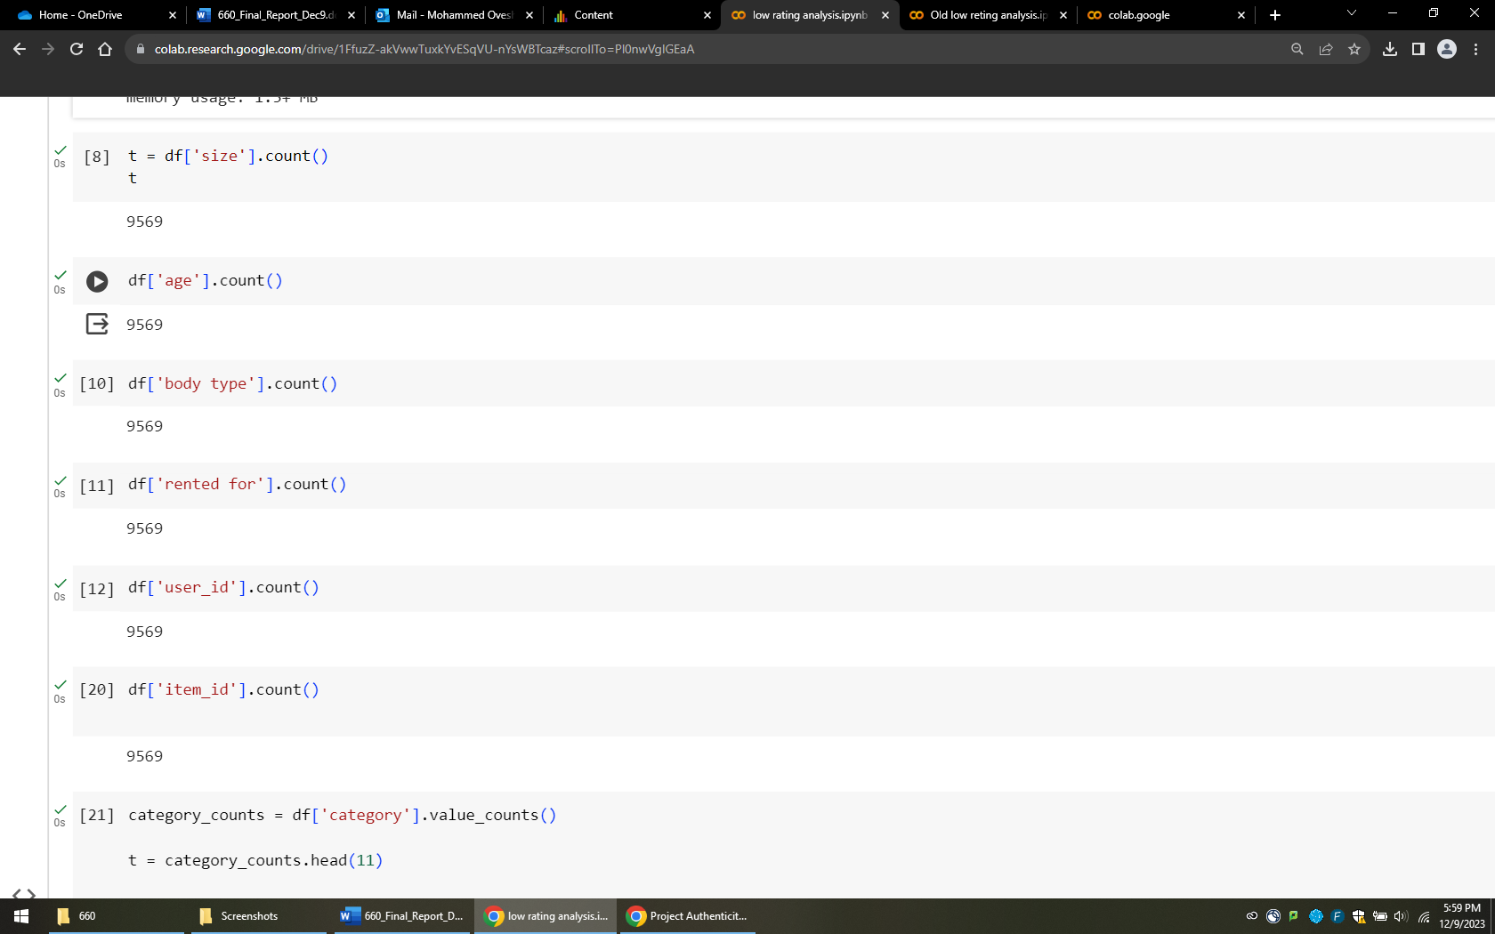

1. Category counts:

* Here we have total 11 categories, below in screenshot it shows how many times it appears in our data.
* Fit-mapping is like each unique value in the ‘fit’ column is associated with a numeric value. That why we used like small is mapped as to 1, fit is assigned to 2 and large is to 3.

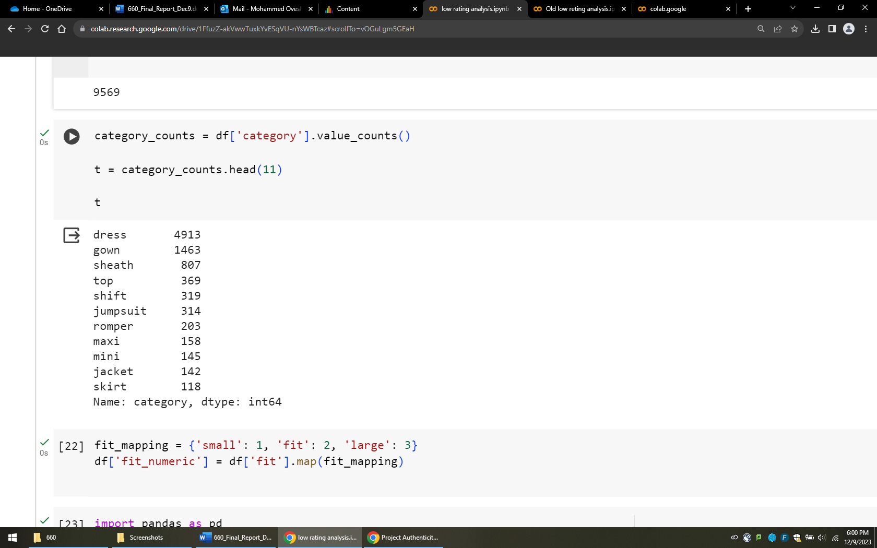

* To early compare our data with different column we did this.

1. Creating Pivot table:

* Creating Pivot table using fit_numeric and category.
* It shoes that how much connection between item like dress and gown has with the fit column so easily we can say that dress hast the almost medium size of feting average

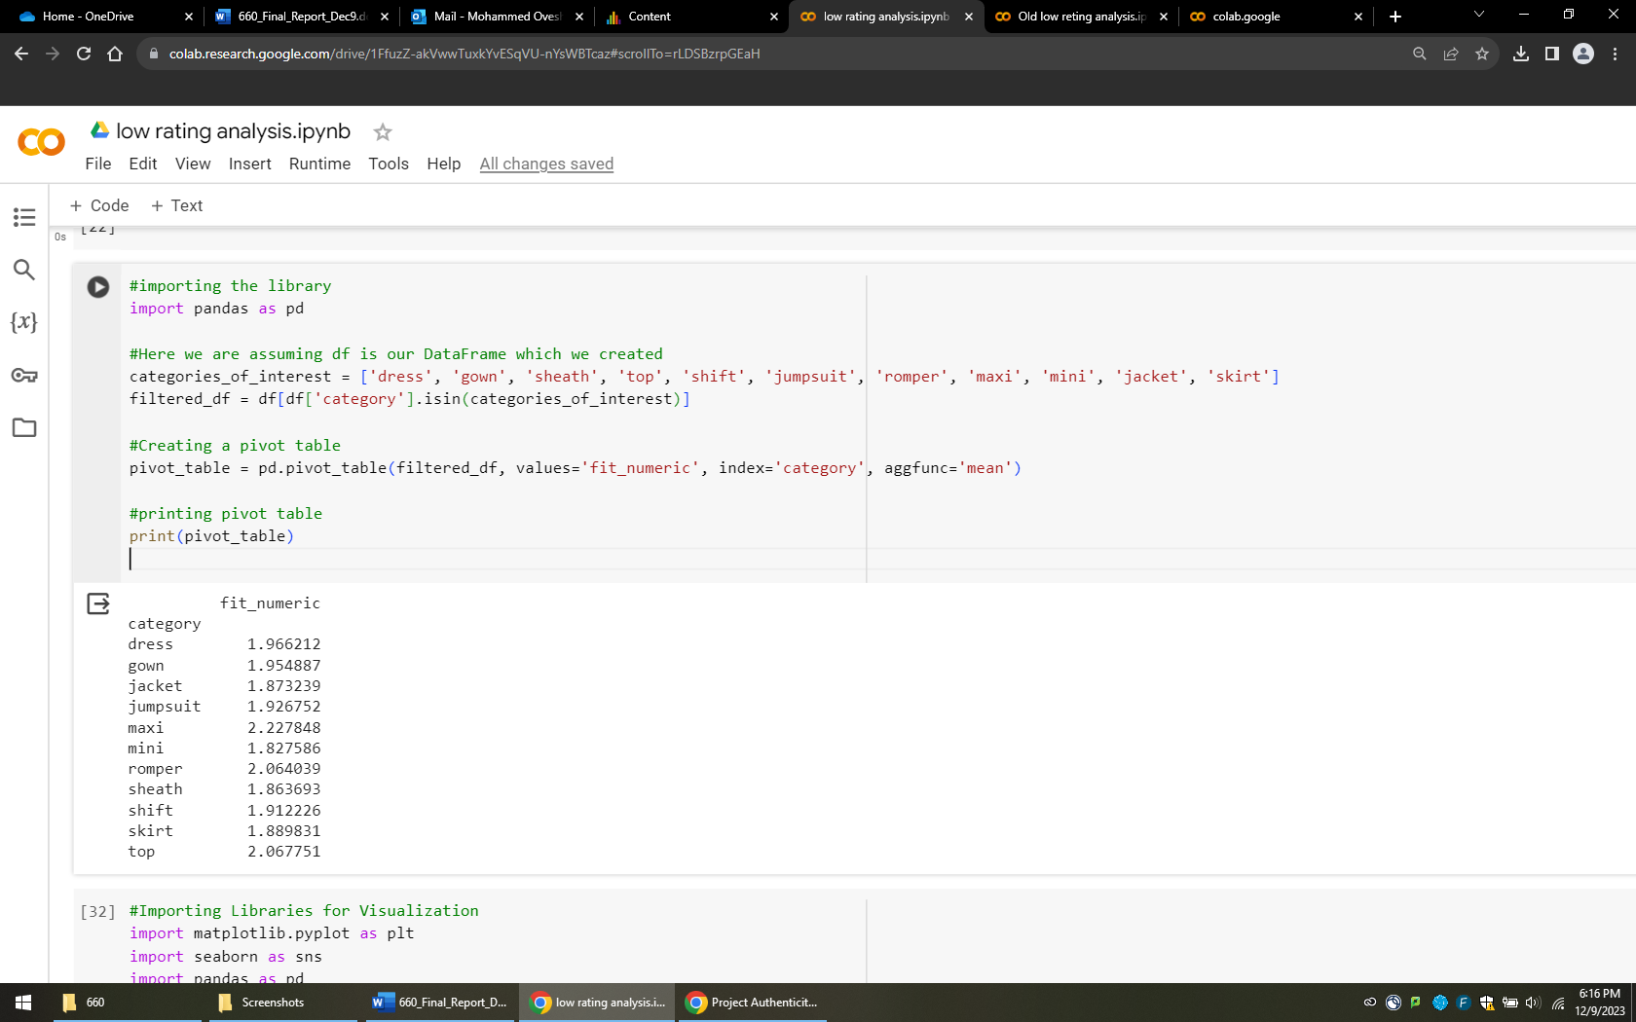

1. Visualization:   
   all 3 categories has the Data represent that majority of people has the age group of 30-40 and there are 20-30 age groups so if company want to focus on age base market, then they should focus on 20-40 age group people for advertising and developing new product for them to get higher profits and sells overall .

* it is similar for all 3 categories

1. **Dress Category:** Below code is to find the Distribution Dress Category according to Age groups. Example: 30-40 age group people like the

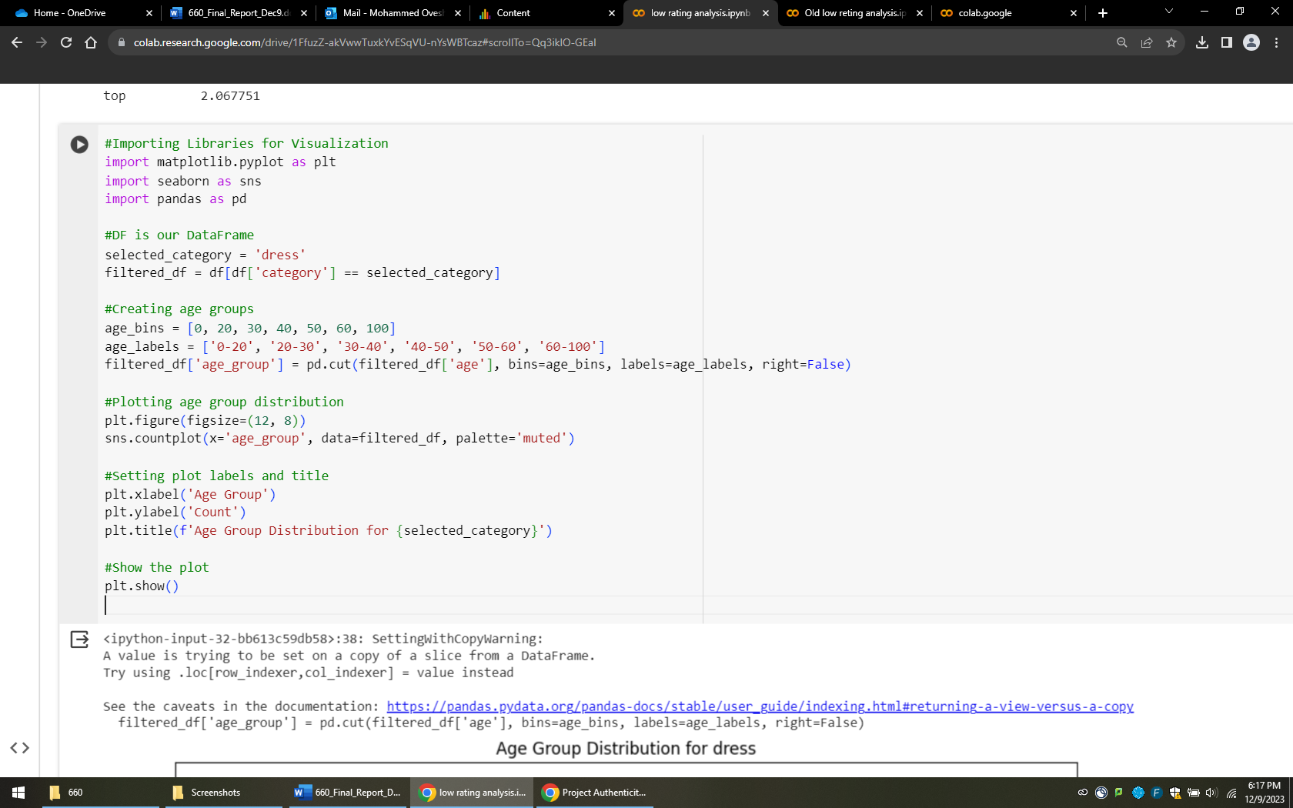

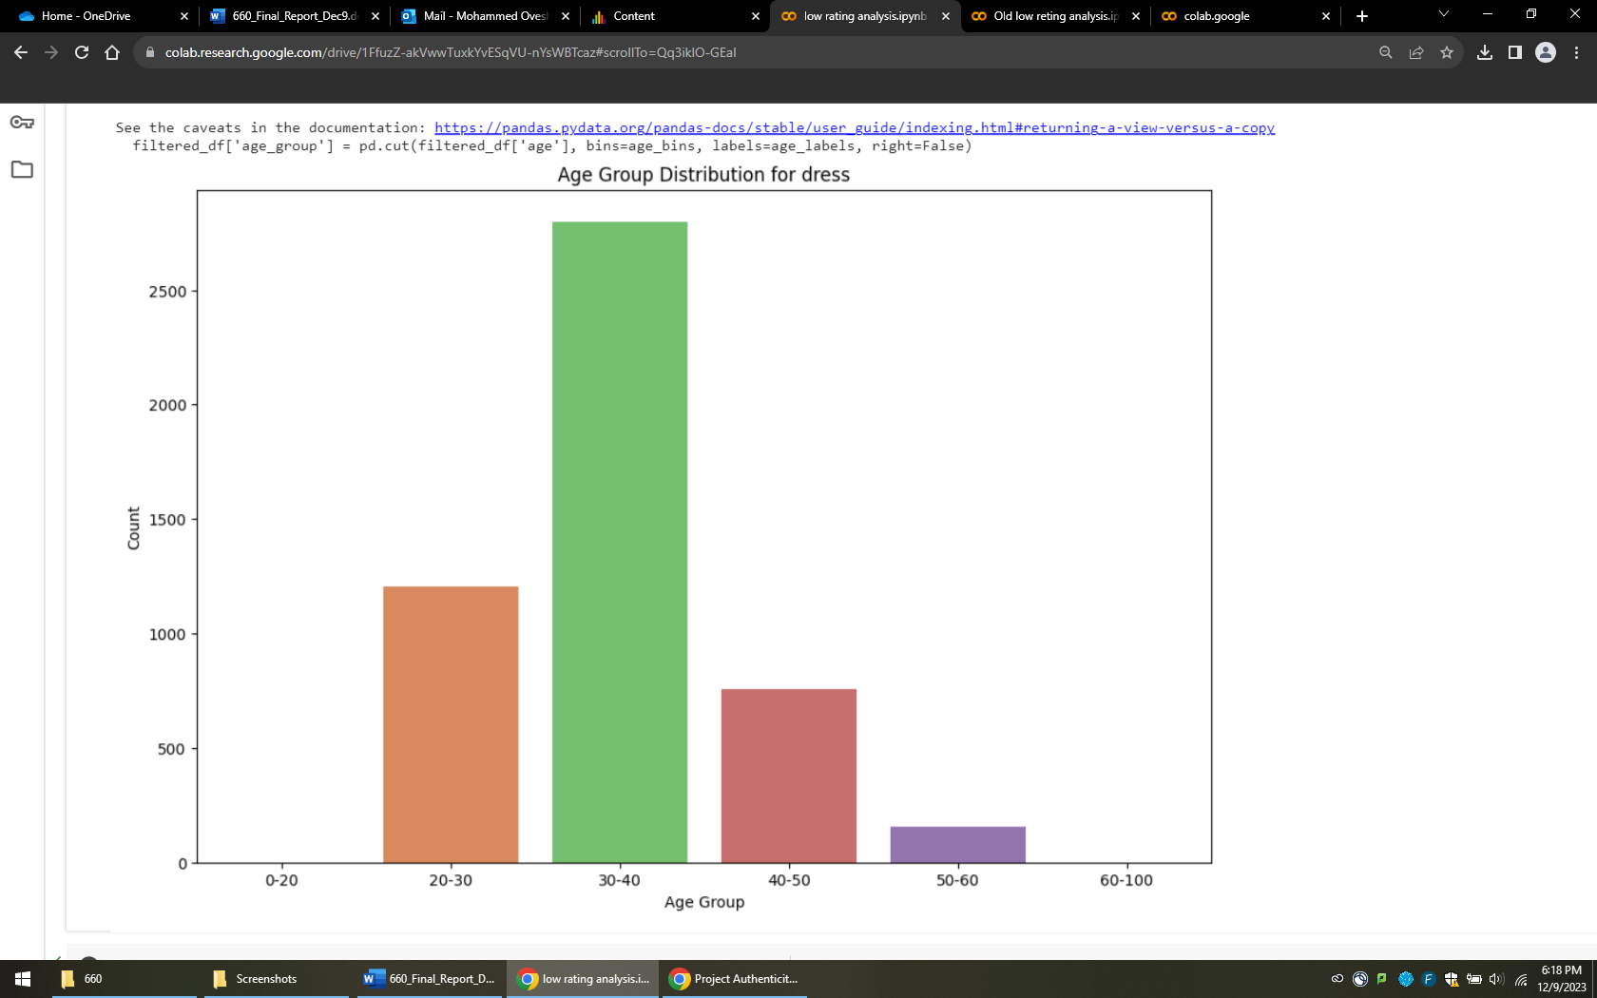

1. **Gown Category:**

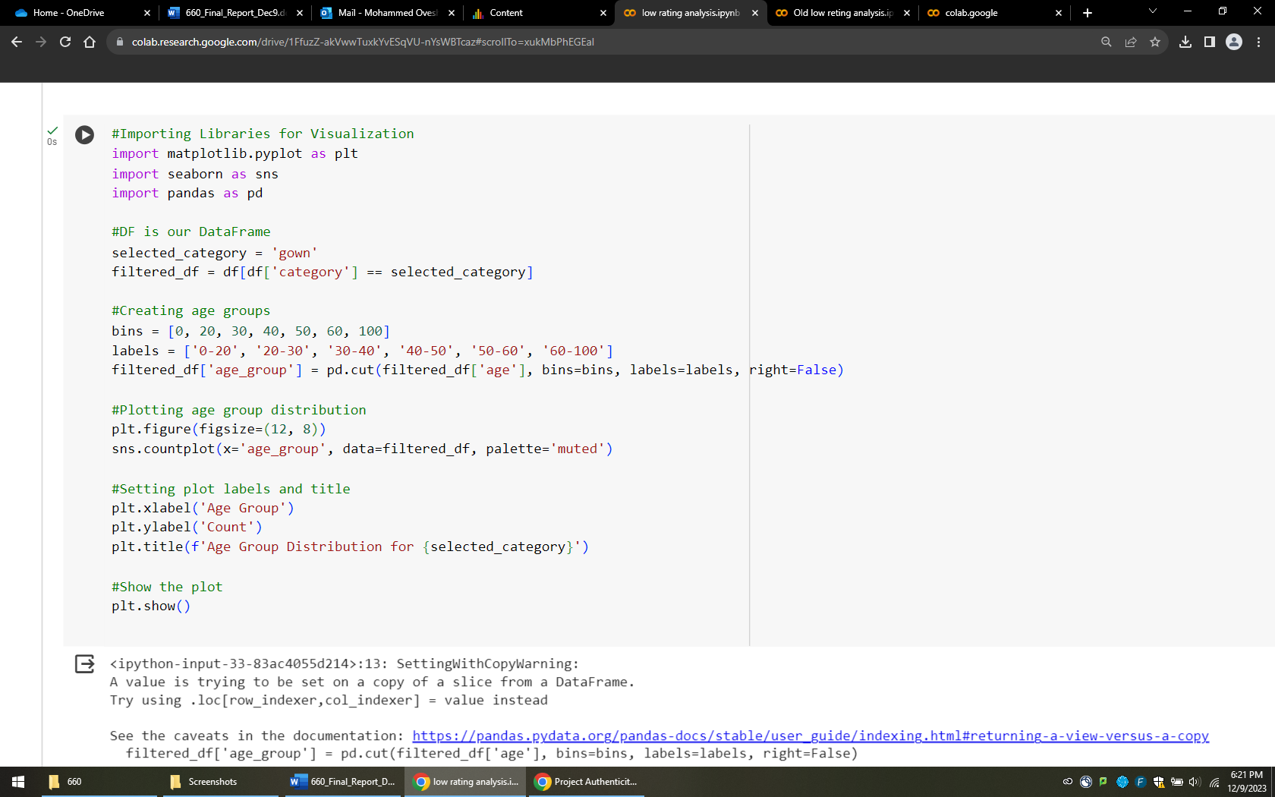

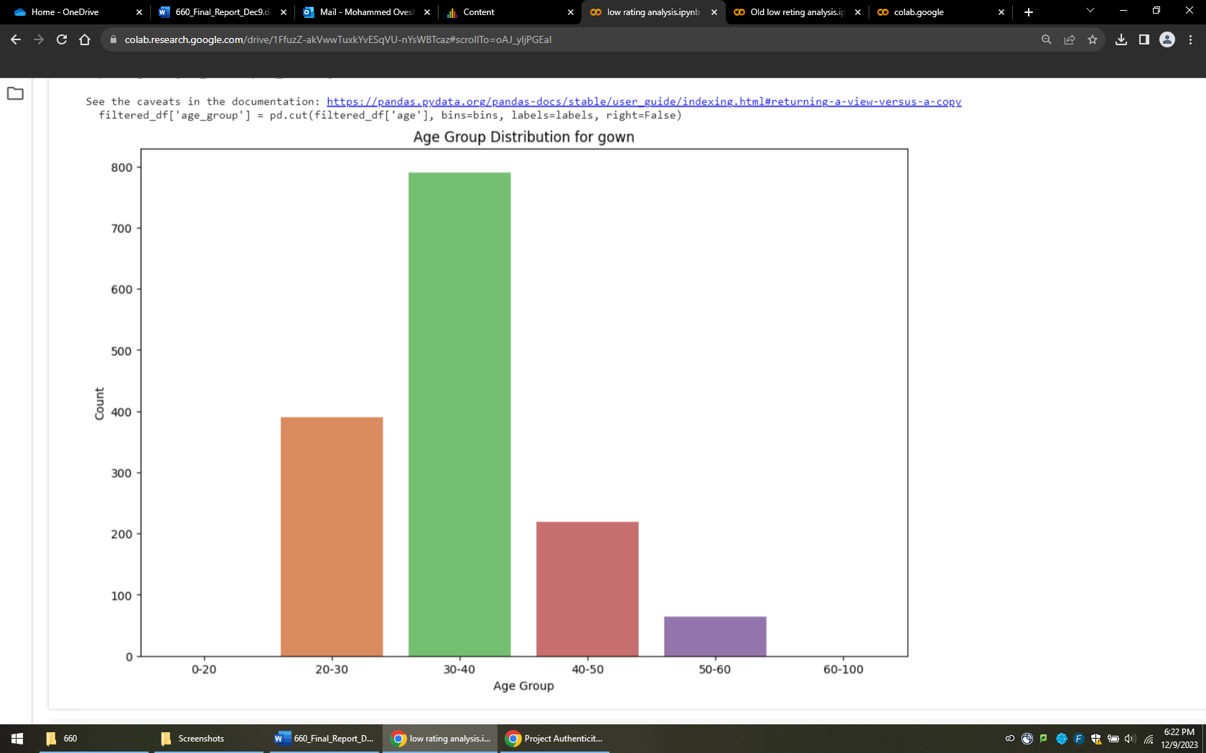

* As per this relation it shows the same result for this.

1. **Sheath Category:**

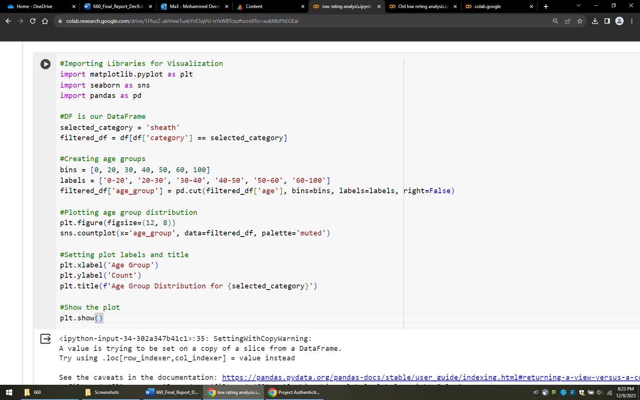

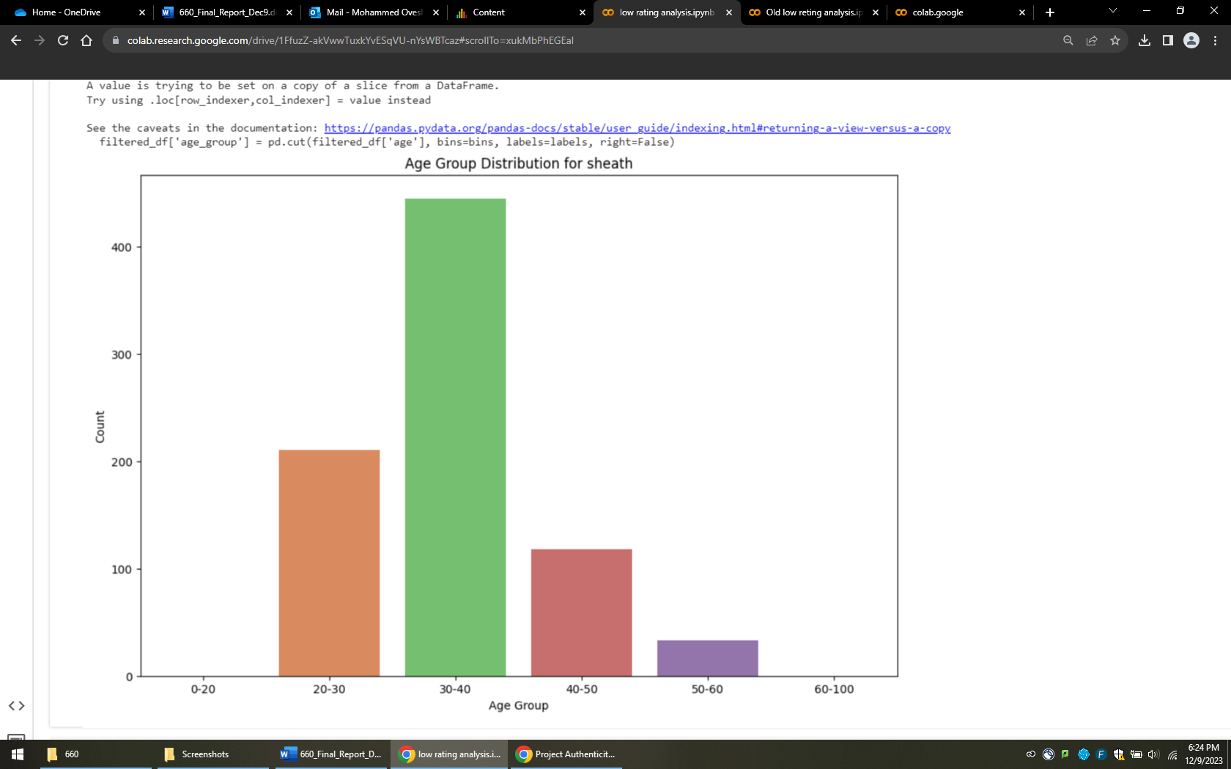

**Now explaining the file name: db_one_data.ipynb**

**Goal of file:** This file I created to establish the deep learning model with the end result, we will show that how efficient our model that we build.

* First, I get the different file with the main file and it has the recommendation and review text in normal form without any null values.

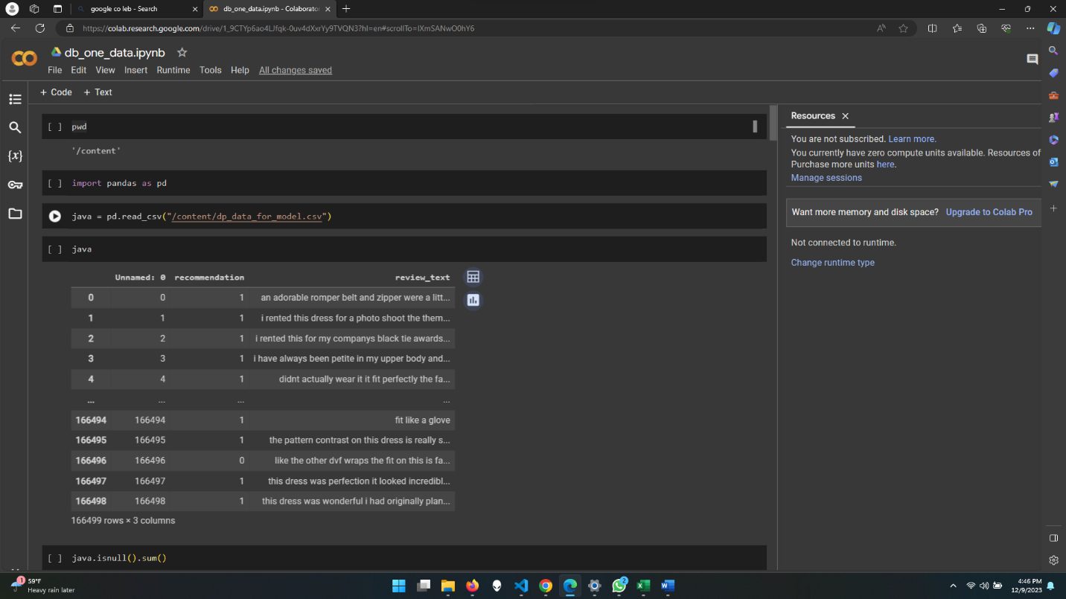

**No null values:**

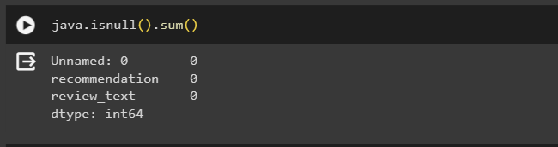

* Now we will do the preprocessing of data for this file which we inserted:

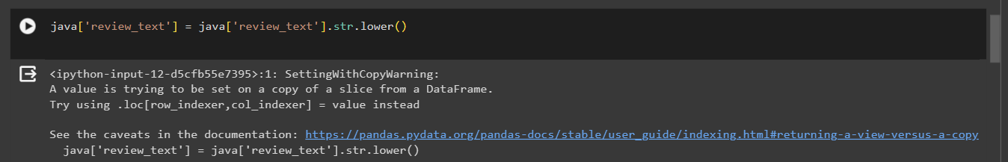

* So over here, we did the main thing that we have to make every word as in lower case to get in one format.

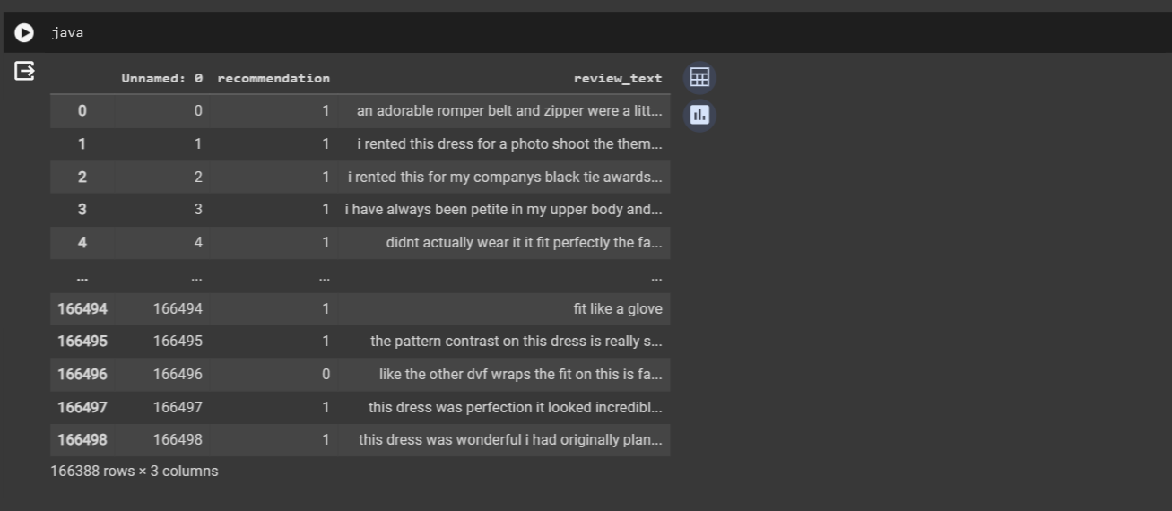

* Using the regular expression for removing the numeric values from the review_text column.

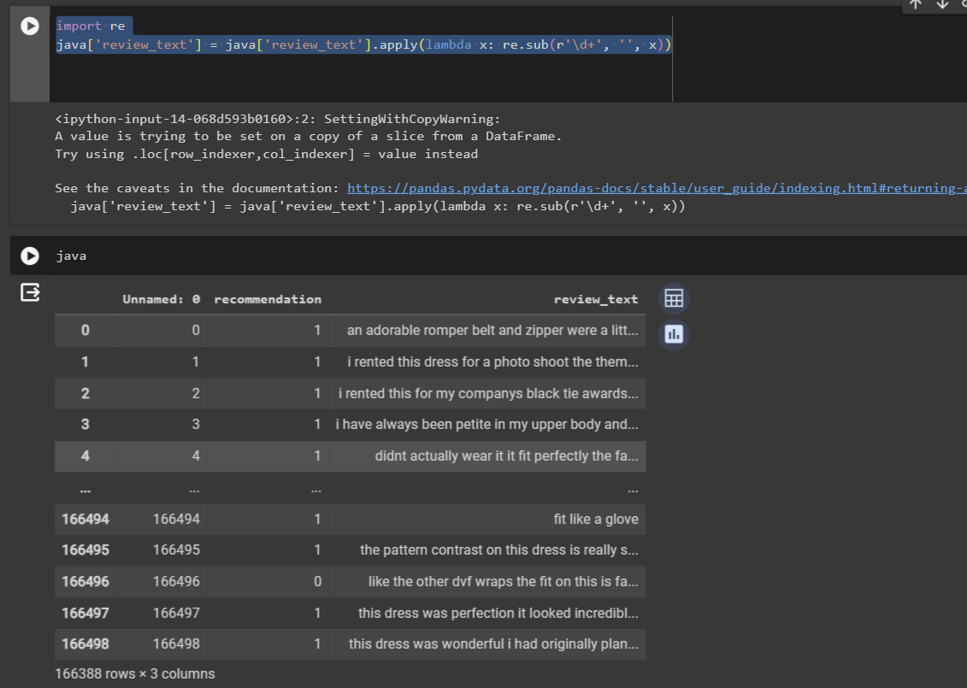

**Now here we are using the stop-word:**

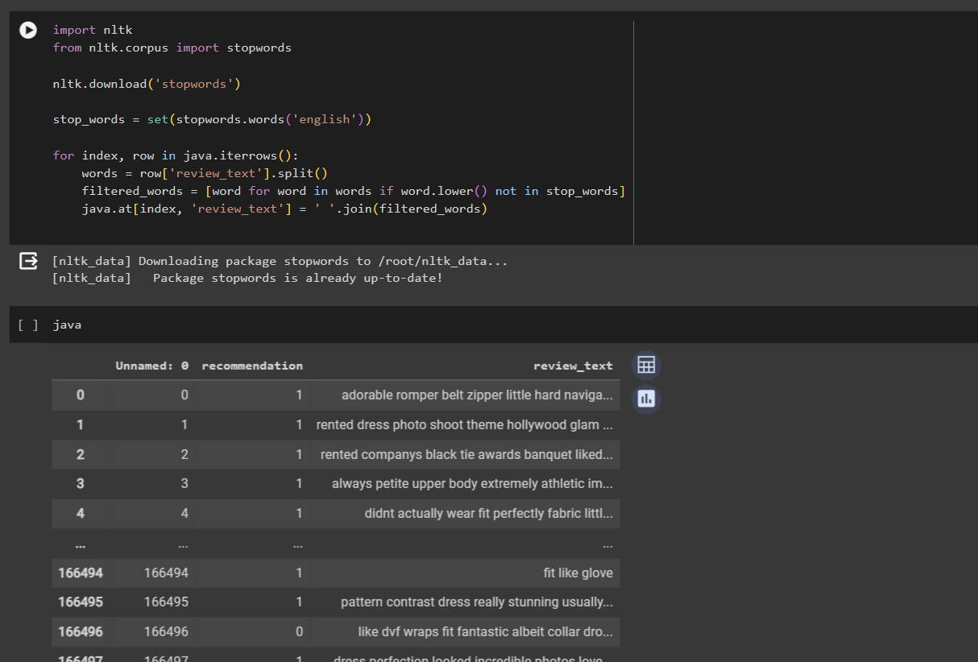

* Firstly, In the screenshot above you will see that, we have downloaded the stop-word from nltk libraries.
* Main concept of this is to remove the common English words from it to reduce the unnecessary words from this, so that we can use it properly and good for the model to reduce the extra unwanted data from this file.
* Here in below screenshot, we used nltk library to use for the WordNetLemmatizer for make words in their main format to get the base form of words to get the understanding of the data basically and gain the main insides easily.

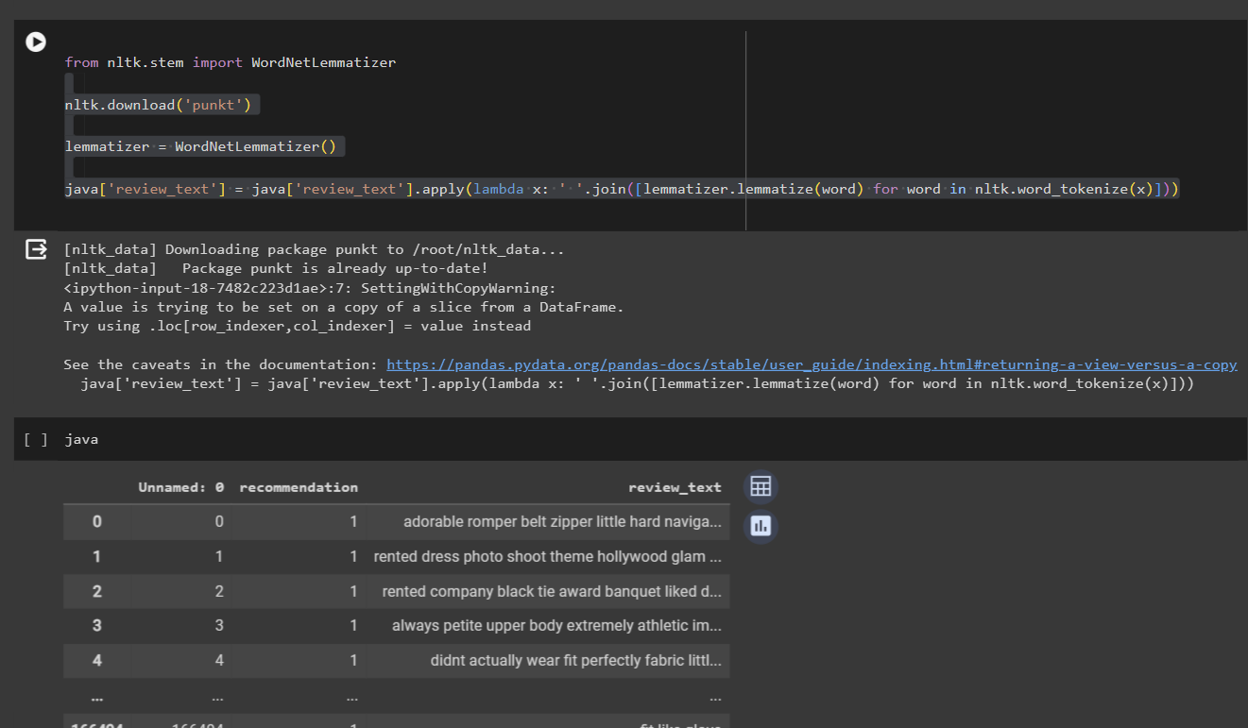

* Now, here we are starting the main thing where first we will understands that how data is represented from previous understating of this project, we can say that we do not have the balance data, but how much unbalance data we have, we can check that, To check we use the data with 0 and 1 values format, so that we can say that is the answer to clarify, that we have to use some methods to get good result because our data is not in 50-50 format or near to that because of that we do not get right result.

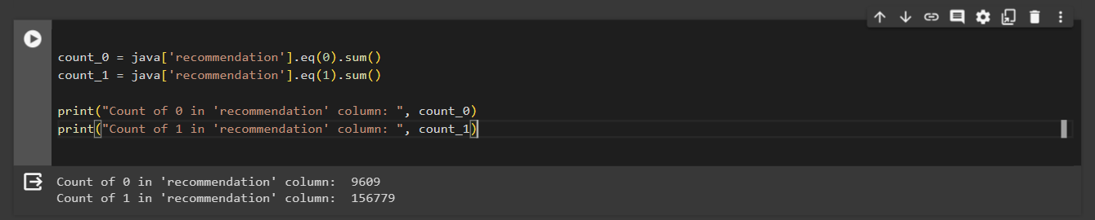

* Now we want to know how many different words our data has and how much unique words it contain our data also, it has to be understandable, So that how should we train our model but this amount of different words it is very hard to run it because it has the amount of capacity in our system, actually it is for future reference but in short this much of unique words are very tough challenge.

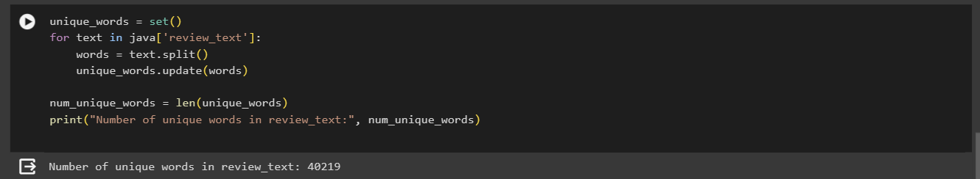

* Now, we will provide both columns in values x and y

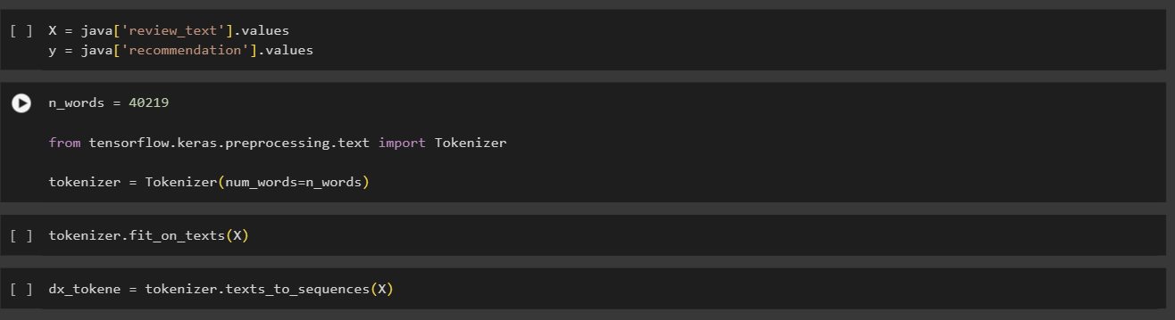

* Here above screenshot, show that each words have a different vector number and it is same as we get how many unique words previously and, it is 40219. And this code represents that each word hast the integer number as an address, so that we can use in the future.
* Padding is use for the maximum length of review_text can except in model. so, we selected highest length of text and if length is not that much for other sentences, then it will replace that with 0, where we selected length of 1300 for this because it shows the memory address.

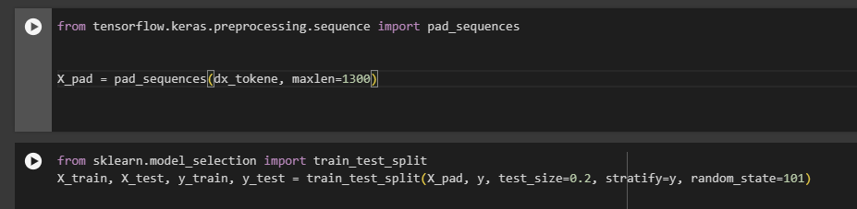

* Finding the words with the integer number to understand and check that these words relate to the integer number or not and we have the maximum figure: 40219.

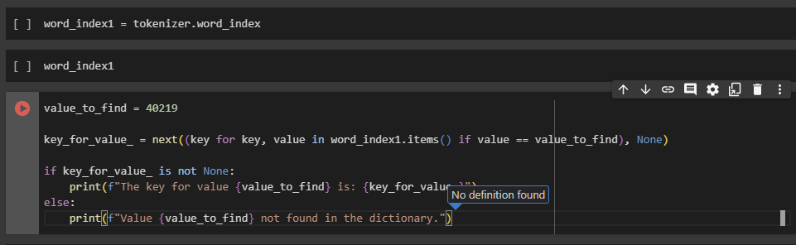

* Now, we have added the length of each sentence in our data, and it shows the right side with the name of num_tokens_dc_count to find the longest length of review text among all.

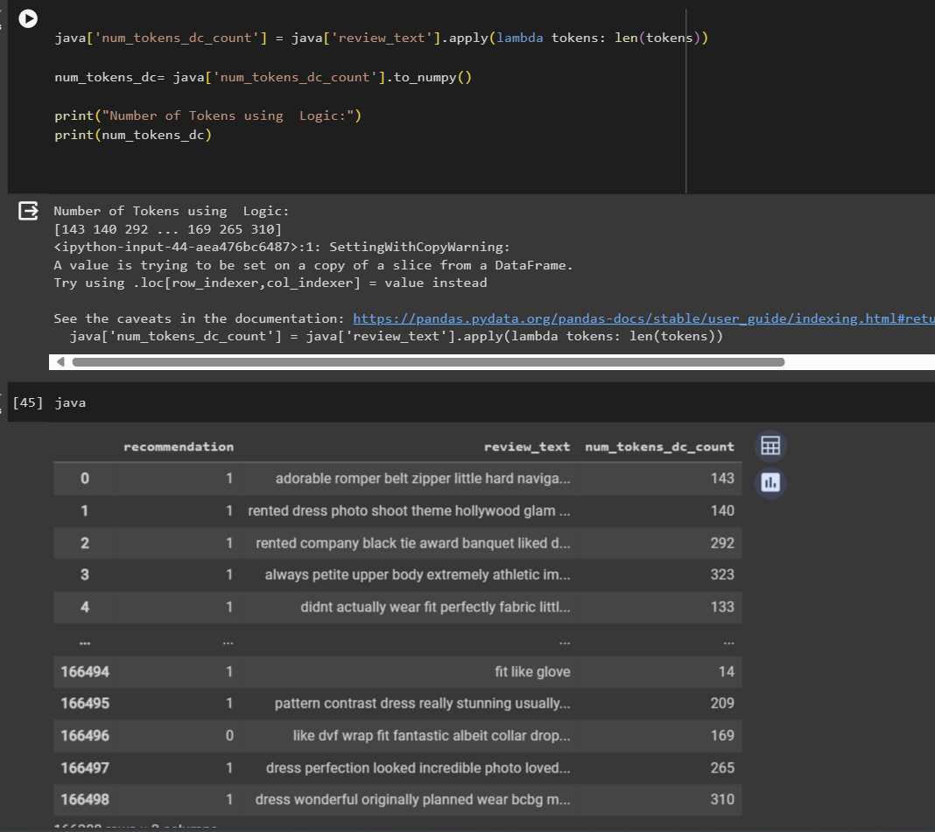

**Word Embedding:**

* Now here, Let’s find the longest length of review_text to add in the word embedding.
* Were it shows the longest one is 1300 in this data and that is stored in the dat1 variable as you can see in below screenshot.

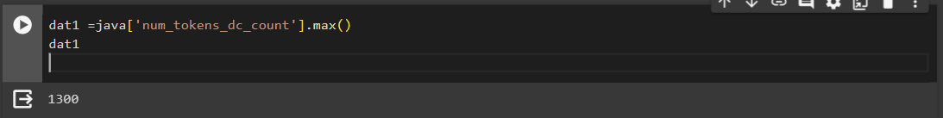

* Here, we are adding the necessary libraries

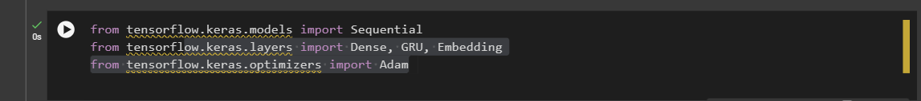

* We added the TensorFlow libraries for our sequential model:

1. Added the **sequential**
2. **dense,GRU,Embedding** for the model layers
3. **Adam** for the optimizer (We selected this because after the research it is the one of the best stable and well maintain optimizer among all and we can set the customize learning rate and that’s important to get good accuracy as per my knowledge).

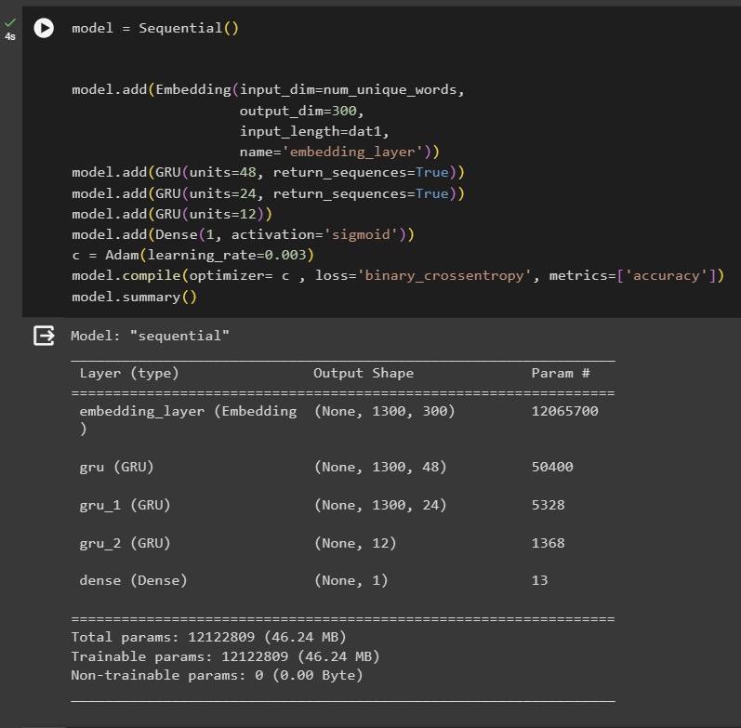

* Now, Here **Important part of Embedding** and **RNN (recurrent neural network).**
* So over here, we get the first input dim from how many unique words in the dataset and as we discussed previously it was 40219.
* which values are stored in the unique_words.

input_dim=num_unique_words

* We selected that as randomly and as per our research it should be between 100 to 300 so we have selected the maximum over here because our data size is huge2.

output_dim=300,

* Now we must add the maximum number of review sentence words length because of that it is 1300 for us right now as we have found and make the different columns in our data for the length of sentence. And, it should be highest and main thing it will take the 0 and remaining places, if it is small sentence then it will take the 0 on that place to cover that area in shorter sentence and because of that we can use longest sentence from data without any bottleneck.

input_length=dat1,

* This is neural network in 3 layers and 4th one for the binarization

model.add(GRU(units=48, return_sequences=True))

model.add(GRU(units=24, return_sequences=True))

model.add(GRU(units=12))

model.add(Dense(1, activation='sigmoid'))

* Also, in the last section it has the activation = sigmoid and it can help in the prediction with activation.

c = Adam(learning_rate=0.003)

model.compile(optimizer= c , loss='binary_crossentropy', metrics=['accuracy'])

* Now this section of code for the optimizer where we selected the accuracy of **0.003**   
  and loss in binary as per our research on this we examine use this when it has the output of 0 or 1 or it is related to one of the answers, we can use that.
* Also, in this section we use the multiple different kind of accuracy to find the right one because it highly depends on the accuracy also when we try the 0.9,0.6,0.3 it shows the very weird answer model react 0 values in f1 score for us and that’s not good sign for the model after several try’s almost 28 try’s and tones of hours we spend to find the right accuracy which has the accuracy over 70% we finally find that one.
* As we know that our data is not properly balance and as per the research, we can use the multiple methods to get the right balance in model and it different model to model and **it has the 94.22 to 0.057 for our model** which is extremely in imbalance and not give good result so we selected the weighted method to train our model .

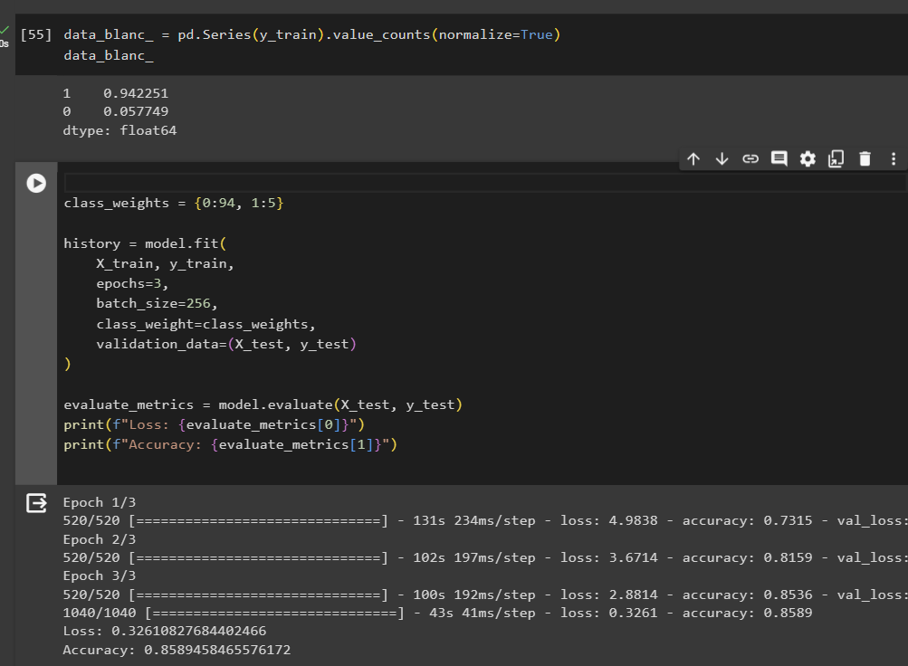

Now here,

epochs=3,

* Now, we selected 3 because we want to know our model works fine with 3 repetition and learning from it
* Yes, it is learning on that because the loss is reduced with each epoch and increase the accuracy so we can say that it is working.

class_weight=class_weights,

* It takes wights in the model evaluation because our model has the imbalance data.

After this model learning:  
Loss: 0.32610827684402466

Accuracy: 0.8589458465576172

* In this below screenshot, we have the result off our model and as per the result everything is good with value 1 and other accuracy for this model however, we already know that we have the very a smaller number of negative datasets to train even that model is doing well **but major concern is can we get the negative results in our model.**

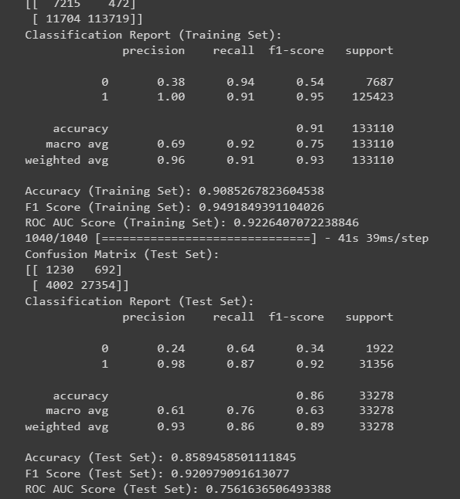

* Also, model has the major advantage in predicting the positive values and that could be problem for future when we are finding the right results.

**Example:**

* Positive sentence can be predicted easily.
* However negative could be not selected easily and shows as the positive instead of negative sentence because we do not have negative data to train.

**The Results:**

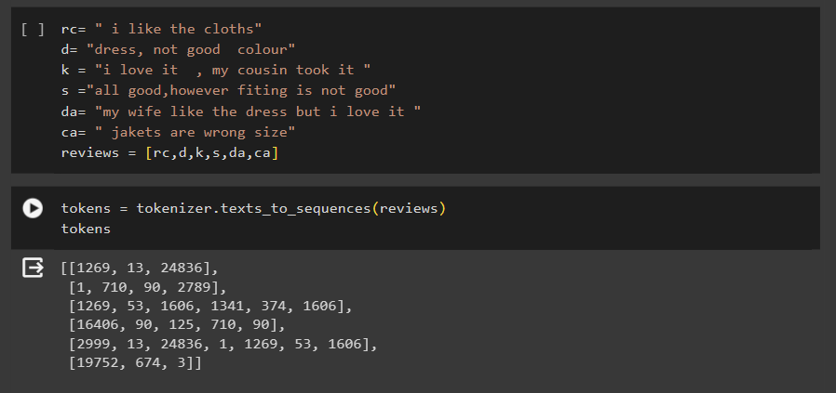

* Over here, we selected the same sentence to check that can we get the right answer from this or not.
* Over here we selected the many reviews and those review for model understanding we must replace that with the unique number of words.
* Replacing with the numbers.

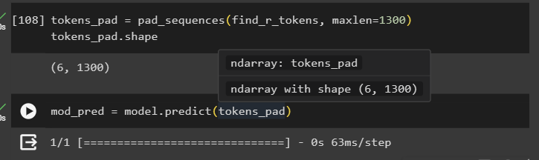

* Now, Here understanding the model shows and give us that number values in the model to get the values where it represents from 0.0 to 1.0
* Where 0.0 is bad
* 1.0 is good

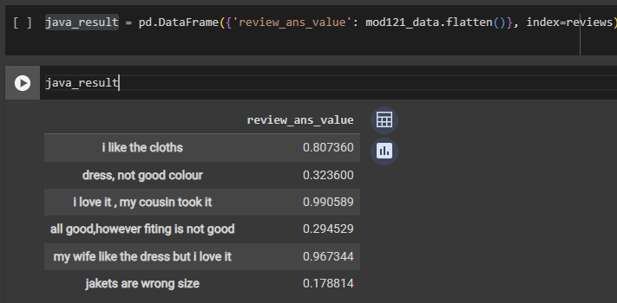

* Now printing the model and we can see above that we have the values on right side
* We have used the panda’s data-frame to make table for this output.
* Where we can see that
  + - All good, however fitting is not good.
      * This example shows that it has the first good sentence, however model know the size is not good so model knows that it is bad review even person like the product, but size is not good, so it is not useful for person.

**Challenges**

* Each person has the different way to represent their review
* Grammatical mistakes
* There is a proper structure for sentence but it’s hard to identify that
* Also, minor change in sentence it changes the meaning

Example: I am happy

I am happy? (yes, this sentence formation is wrong as grammatical, but we can see this kind of sentence formation because of that we have to use the learning base model on already available data)

* Finding the right accuracy for this model we try many different tries to get the best result
* Cleaning data with the more then 5k different items and some columns must be replaced with mean.
* So, we must find each item vice mean for particular column to get the best replacement of null value.
* Understanding and finding the best solution for this also learning how to implement how to make model and set the values for this are very challenging.
* Computer limitations:
  + - In several time our both computers have the shut down because of huge data and we must run from starting that take more time
* Also, model training takes tones of time to train the model in image u can see that it shows etc. more than 3 hours, and we selected 10 epochs then it will be 30 hours.

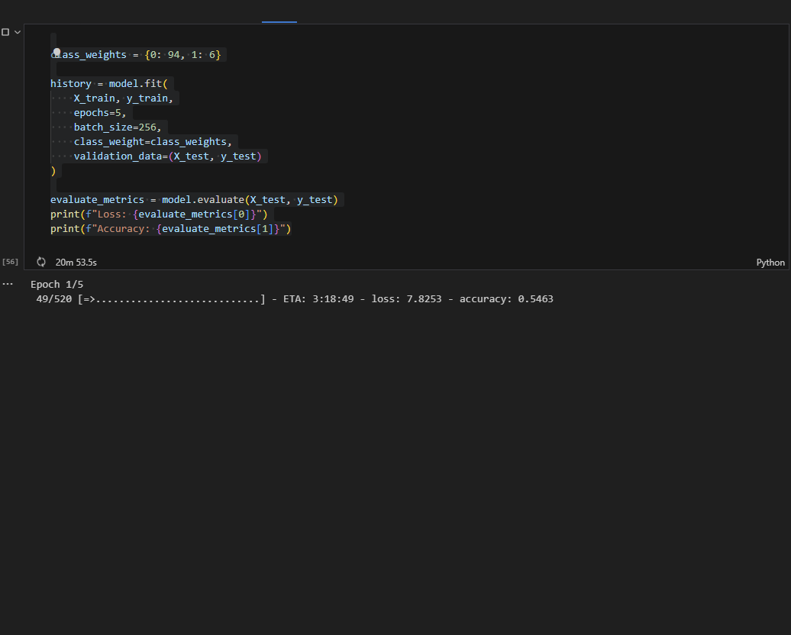

**Reference:**

<https://developers.google.com/machine-learning>

To basic understanding of machine learning and how we can we prepare the model also basic information like embedding, logistic regression, neural network, training neural network.

<https://www.kaggle.com/code/chewzy/tutorial-how-to-train-your-custom-word-embedding>

How to start with personal word embedding because every data is different and if u want accurate result with your data you have to add the real data in training so we can achieve that result or find the nearest result of this.

<https://machinelearningmastery.com/develop-word-embedding-model-predicting-movie-review-sentiment/>

Training embedding layers

Loading and learning of reviews

<https://www.analyticsvidhya.com/blog/2022/01/sentiment-analysis-with-lstm/>

This website shows the sentimental analysis with deep learning with how to train model and how to conclude your result to understand how things are working in customer learning model!

Also, RNN model how it works and enhance the understanding of model by learning each time how sentence is formed and how it connected with other.